|  |  |
| --- | --- |
| PINPOINT/SES Event Dashboard | AWS DUE Specialist Solutions Architect |

# Pinpoint – Engagement Event Dashboard

Table of Contents

Pinpoint – Engagement Event Dashboard 1

Solution Summary 2

Background 2

Solution 2

Use case(s) 2

Considerations 2

High Level solution Architecture: 2

Steps to implement the solution 3

Step 1 – Create AWS account & Pinpoint Project 3

Step 2 – Create S3 bucket for Lambda code and upload the Zip file 4

Step 3 – Deploy Cloud formation template for Event dashboard solution 4

Step 4 – Create Amazon Quicksight engagement Dashboard 6

Cost for Event dashboard solution 15

Conclusion 15

Next steps 15

Extending the solution 15

Appendix -1 15

# Solution Summary

## Background

Currently Amazon Pinpoint and Amazon SES do have a dashboard which provides user engagement data at an aggregated level but not at the individual event or recipient level. This leads to a lot of problem for production support teams to debug individual engage events also Marketers/business users could not gather detail engagement analytics with each and every user. This solution will elaborate on how to create a detail event engagement dashboard for Pinpoint/SES using Amazon Quicksight.

## Solution

This Solution extends [DUE events database](https://aws.amazon.com/solutions/implementations/digital-user-engagement-events-database/) solution allowing all the events queried through Amazon Athena which will be integrated to Amazon Quicksight to display engagement events. This solution can be implemented into four steps in chronological order.

1. **Set up event database solution**
2. **Deploy the Athena View CloudFormation template**
3. **Create S3 bucket for Lambda code and upload the code Zip file**
4. **Create dashboard using Amazon Quicksight for engagement events (Customers need to follow all the pointers mentioned within this step to create their own engagement dashboard)**

## Use case(s)

Event dashboard solutions have following use cases: -

* Deep dive into engagement insights. (eg: SMS events, Email events, Campaign events, Journey events)
* The ability to view engagement events at the individual user level.
* Data/process mining turn raw event data into useful marking insights.
* User engagement benchmarking and end user event funneling.
* Compute campaign conversions (post campaign user analysis to show campaign effectiveness)
* Build funnels that shows user progression

## Considerations

1. [DUE event data base solution](https://aws.amazon.com/solutions/implementations/digital-user-engagement-events-database/) must be setup 1st.
2. Customers should be prepared to purchase Amazon Quicksight because it has its own set of [costs](https://aws.amazon.com/quicksight/pricing/) which is not covered within Amazon Pinpoint cost.

## High Level solution Architecture:

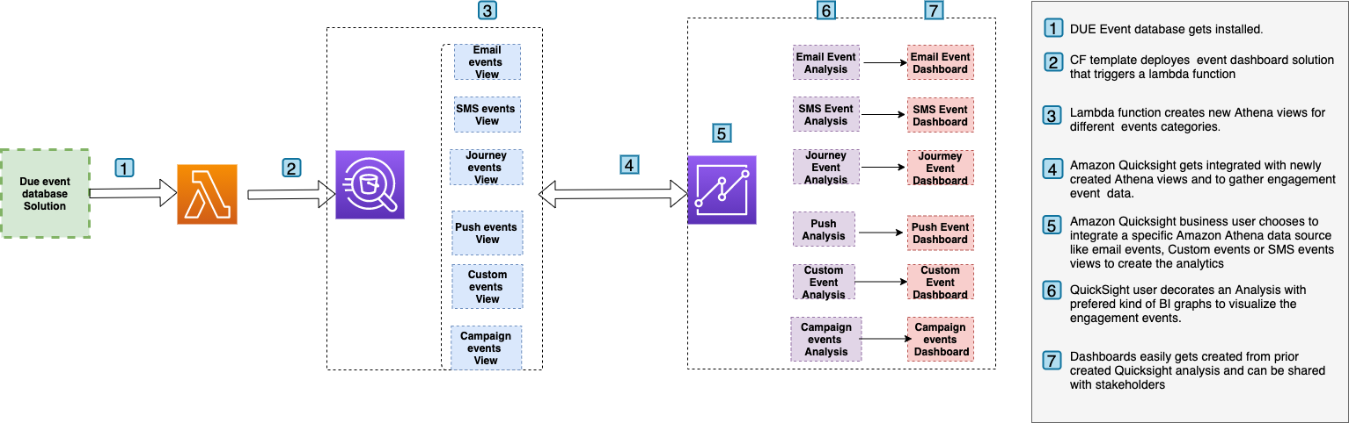

## Steps to implement the solution

### Step 1 – Create AWS account & Pinpoint Project

As part of this step customers need to implement [DUE Event database solution](https://aws.amazon.com/solutions/implementations/digital-user-engagement-events-database/) as **the current solution (DUE event dashboard)** **is an extension of DUE event database solution**. The basic assumption here is that the customer has already configured Amazon Pinpoint project or Amazon SES is setup before implementing this step.

The steps required to implement an event dashboard solution are as follows.

1. Follow the steps mentioned in[Event database solution](https://aws.amazon.com/solutions/implementations/digital-user-engagement-events-database) to implement the complete stack. Prior installing the complete stack copy and save the name Athena events database name as shown in the diagram. For my case it is **due_eventdb**. Database name is required as an input parameter for the current Event Dashboard solution.

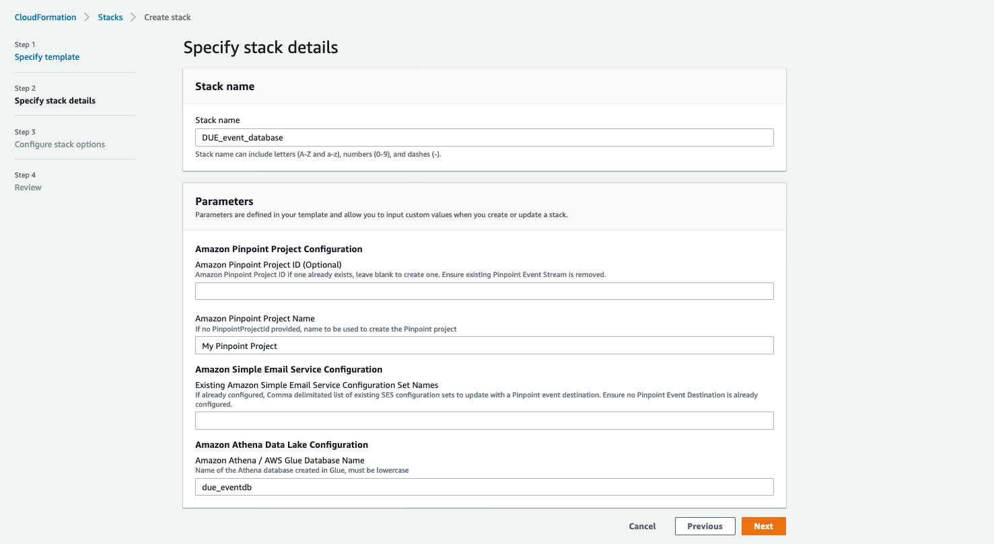



1. Once the solution is deployed, navigate to the output page of the cloud formation stack, and copy, and save the following information, which will be required as input parameters in step 2 of the current Event Dashboard solution.

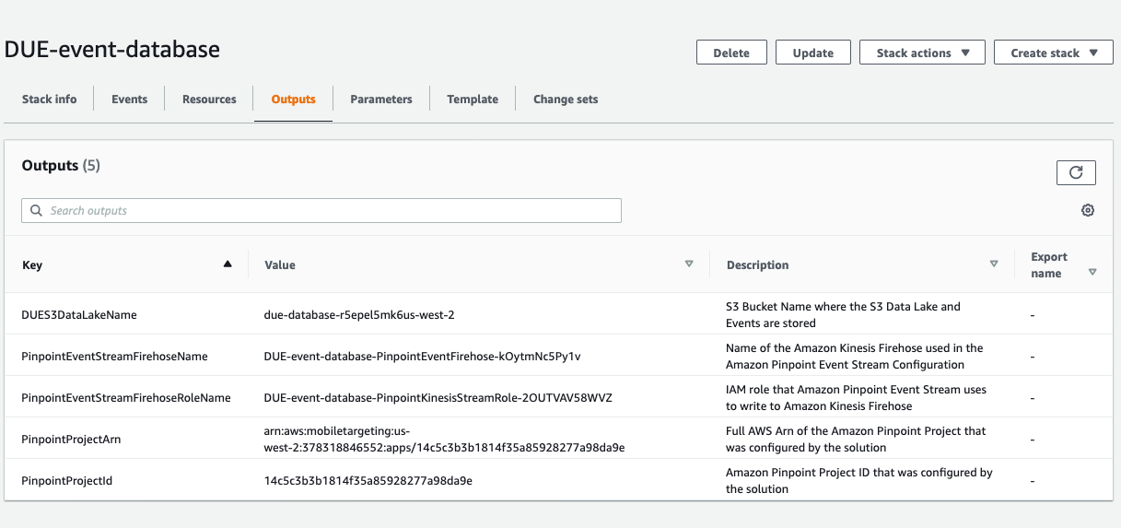



### Step 2 – Create S3 bucket for Lambda code and upload the Zip file

To use the current event dashboard solution, upload a lambda code zip file to an S3 location in the same region as the Amazon Pinpoint project and Event database solution. The Code Zip file's name is **"custom-view-builder.zip"** and you can get it from AWS samples. [<Link>.](https://github.com/Satya-Git3105/Due-events-dashboard) Once the download is complete, proceed with the steps outlined below;

1. Create an S3 bucket in the same region where you have your Pinpoint projects and give it a unique name.
2. Place the file “custom-view-builder.zip” in the root folder.
3. Make a note of the same S3 bucket name; this will be required as an input parameter for the Event dashboard solution. In our case it is **“Lambdacodecustomview”**
4. This code will be executed only once during the solution deployment.

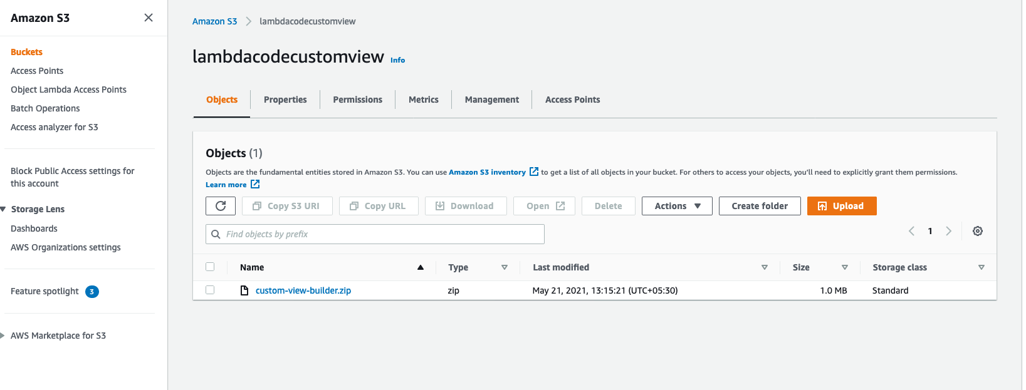



### Step 3 – Deploy Cloud formation template for Event dashboard solution

This step generates a number of new Amazon Athena views that will serve as a data source for Amazon Quicksight. Continue with the following actions.

1. Download the cloud formation template(**“Event-dashboard.template”**) from AWS samples. <AWS samples Link>
2. Navigate to Cloud formation page in AWS console, click up right on “Create stack” and select the option “With new resources (standard)”
3. Leave the “Prerequisite – Prepare template” to “Template is ready” and for the “Specify template” option, select “Upload a template file”. On the same page, click on “Choose file”, browse to find the file “**Event-dashboard.template**” file and select it. Once the file is uploaded, click “Next” and deploy the stack

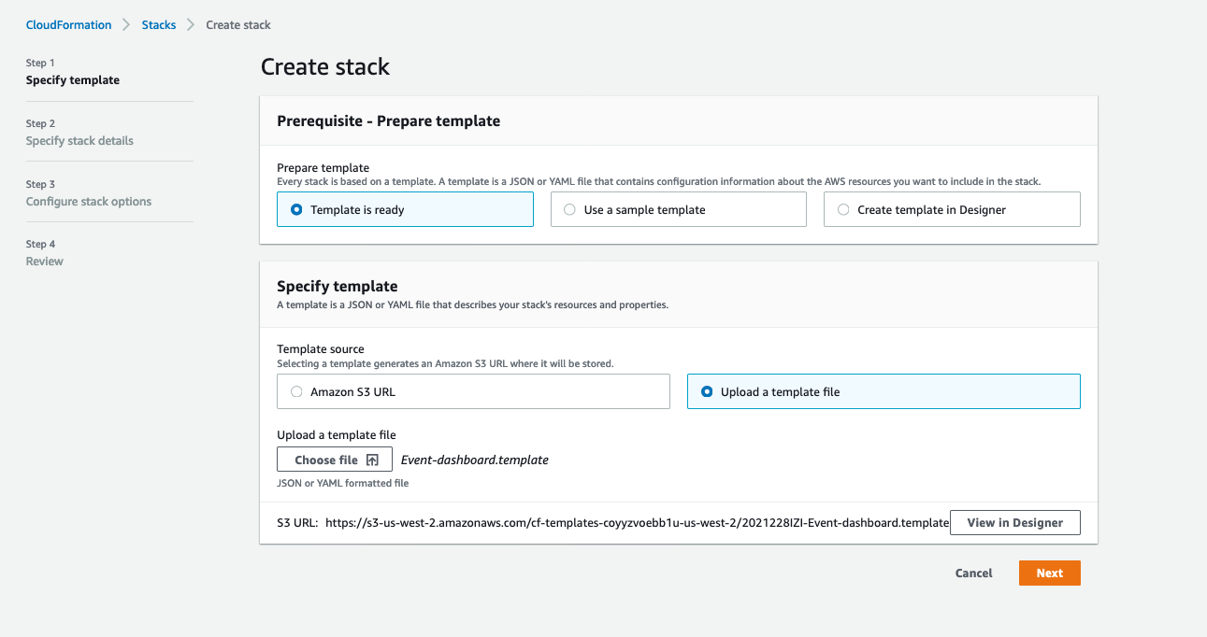

1. Enter following information under the section “Specify stack details”:
   * 1. EventAthenaDatabaseName - As mentioned in Step **1-a.**
     2. LambdaCodes3bucket – S3 bucket name where you have installed the code zip file. Mentioned in **Step 2-d**
     3. S3DataLogBucket- As mentioned in Step **1-b**

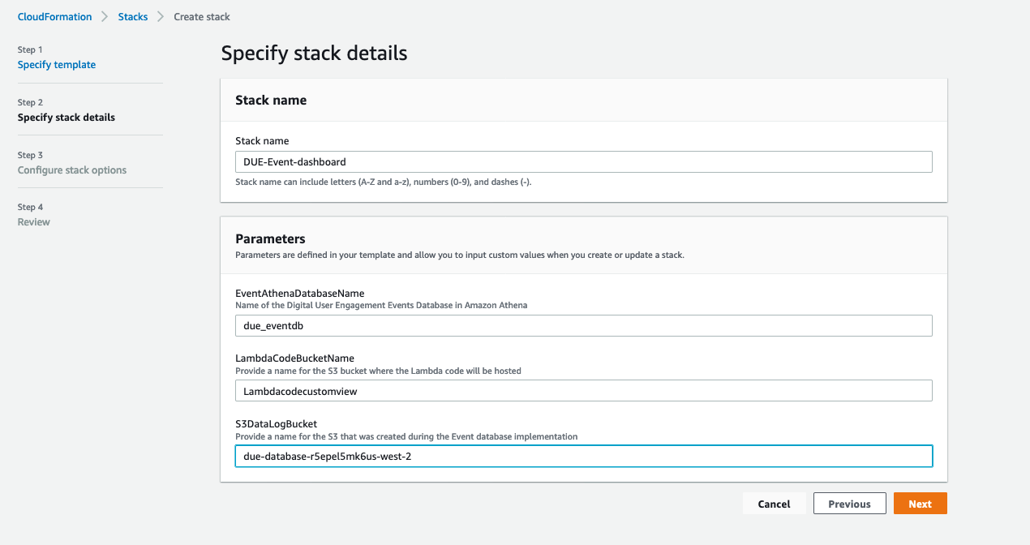



1. This solution will create additional 5 Athena views which are
   1. All_email_events
   2. All_SMS_events
   3. All_custom_events (Custom events can be Mobile app/WebApp/Push Events)
   4. All_campaign_events
   5. All_journey_events

### Step 4 – Create Amazon Quicksight engagement Dashboard

This step walks you through the process of creating an Amazon Quicksight dashboard for Amazon Pinpoint engagement events using the Athena views you created in step**-2**

1. To Setup Amazon Quicksight for the 1st time please follow Appendix - 1 (this process is not needed if you have already setup Amazon Quicksight). Please make sure you are an Amazon Quicksight Administrator.
2. Go/search Amazon Quicksight on AWS console.

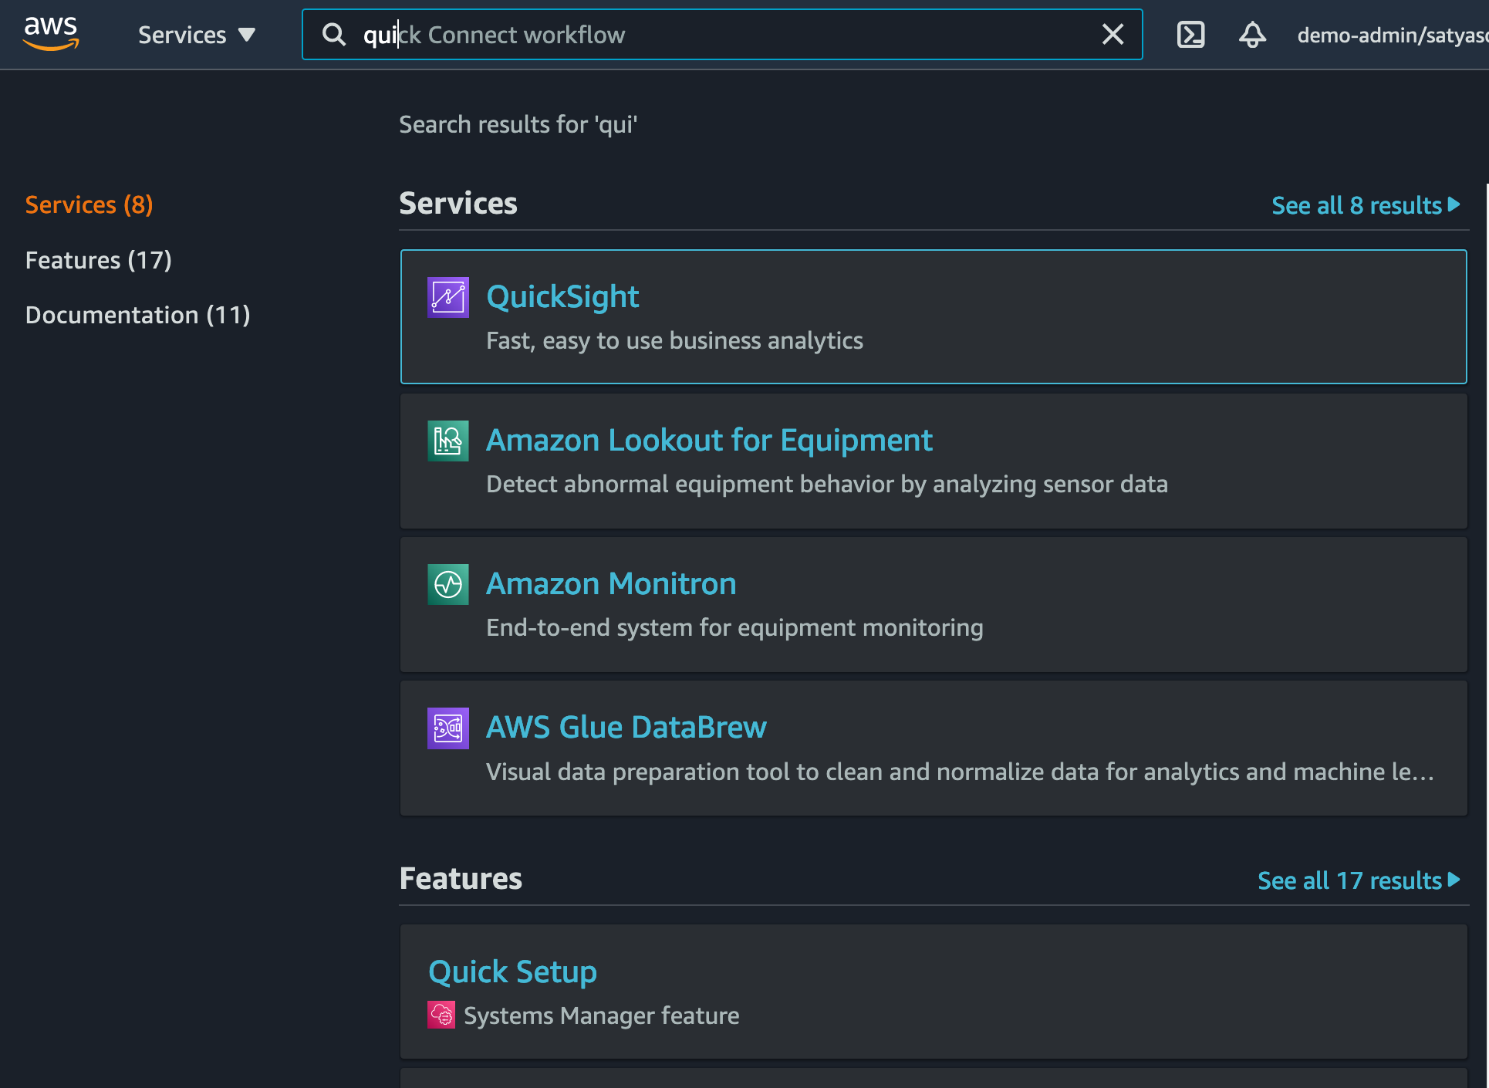

1. Create New Analysis and select “New dataset”

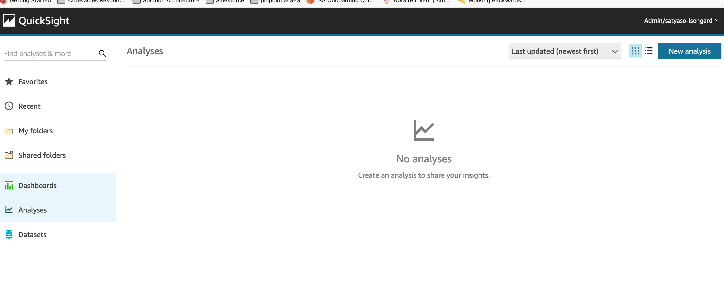

1. Select Athena as data source

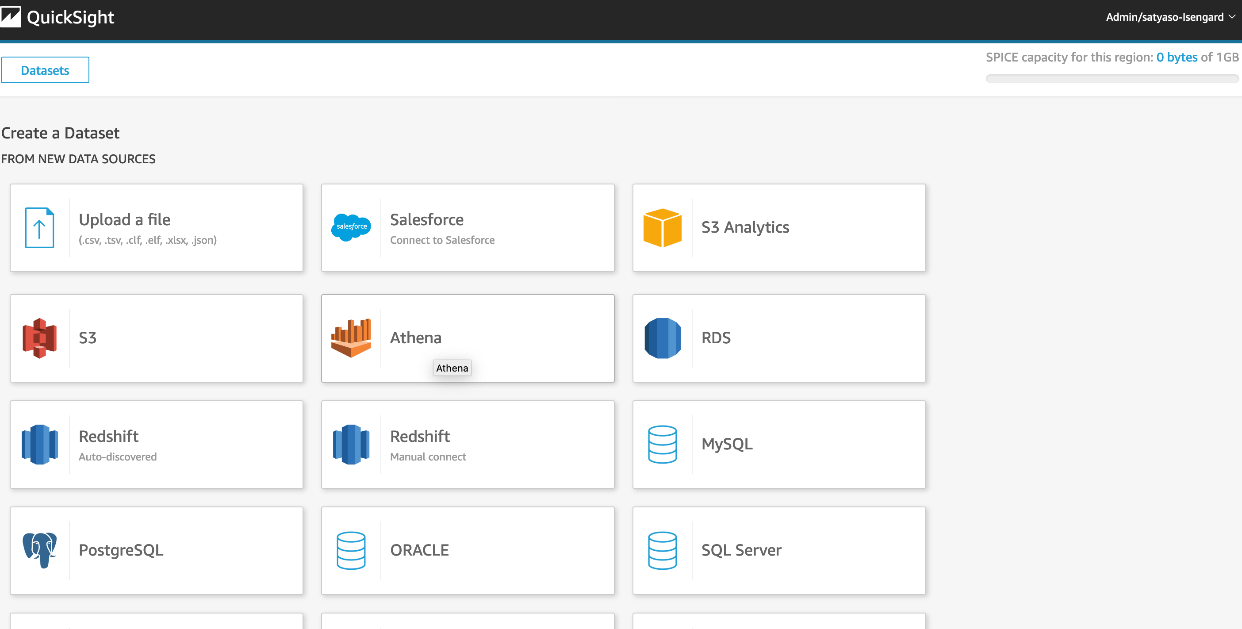

1. As a next step, you need to select what all analysis you need for respective events. This solution provides option to create 5 different set of analysis as mentioned in Step 2. They are a/All email events, b/All SMS Events, c/All Custom Events (Mobile/Web App, web push etc), d/ All Campaign events, e/All Journey events. Dashboard can be created from Quicksight analysis and same can be [shared](https://docs.aws.amazon.com/quicksight/latest/user/sharing-a-dashboard.html) among the organization stake holders. Following are the steps to create analysis and dashboards for different type of events.
2. **Email Events** –
   1. For all email events, name the analysis "All-emails-event-analysis" (this can be any kind of customer preferred nomenclature), select Athena workgroup as primary, and then create a data source.

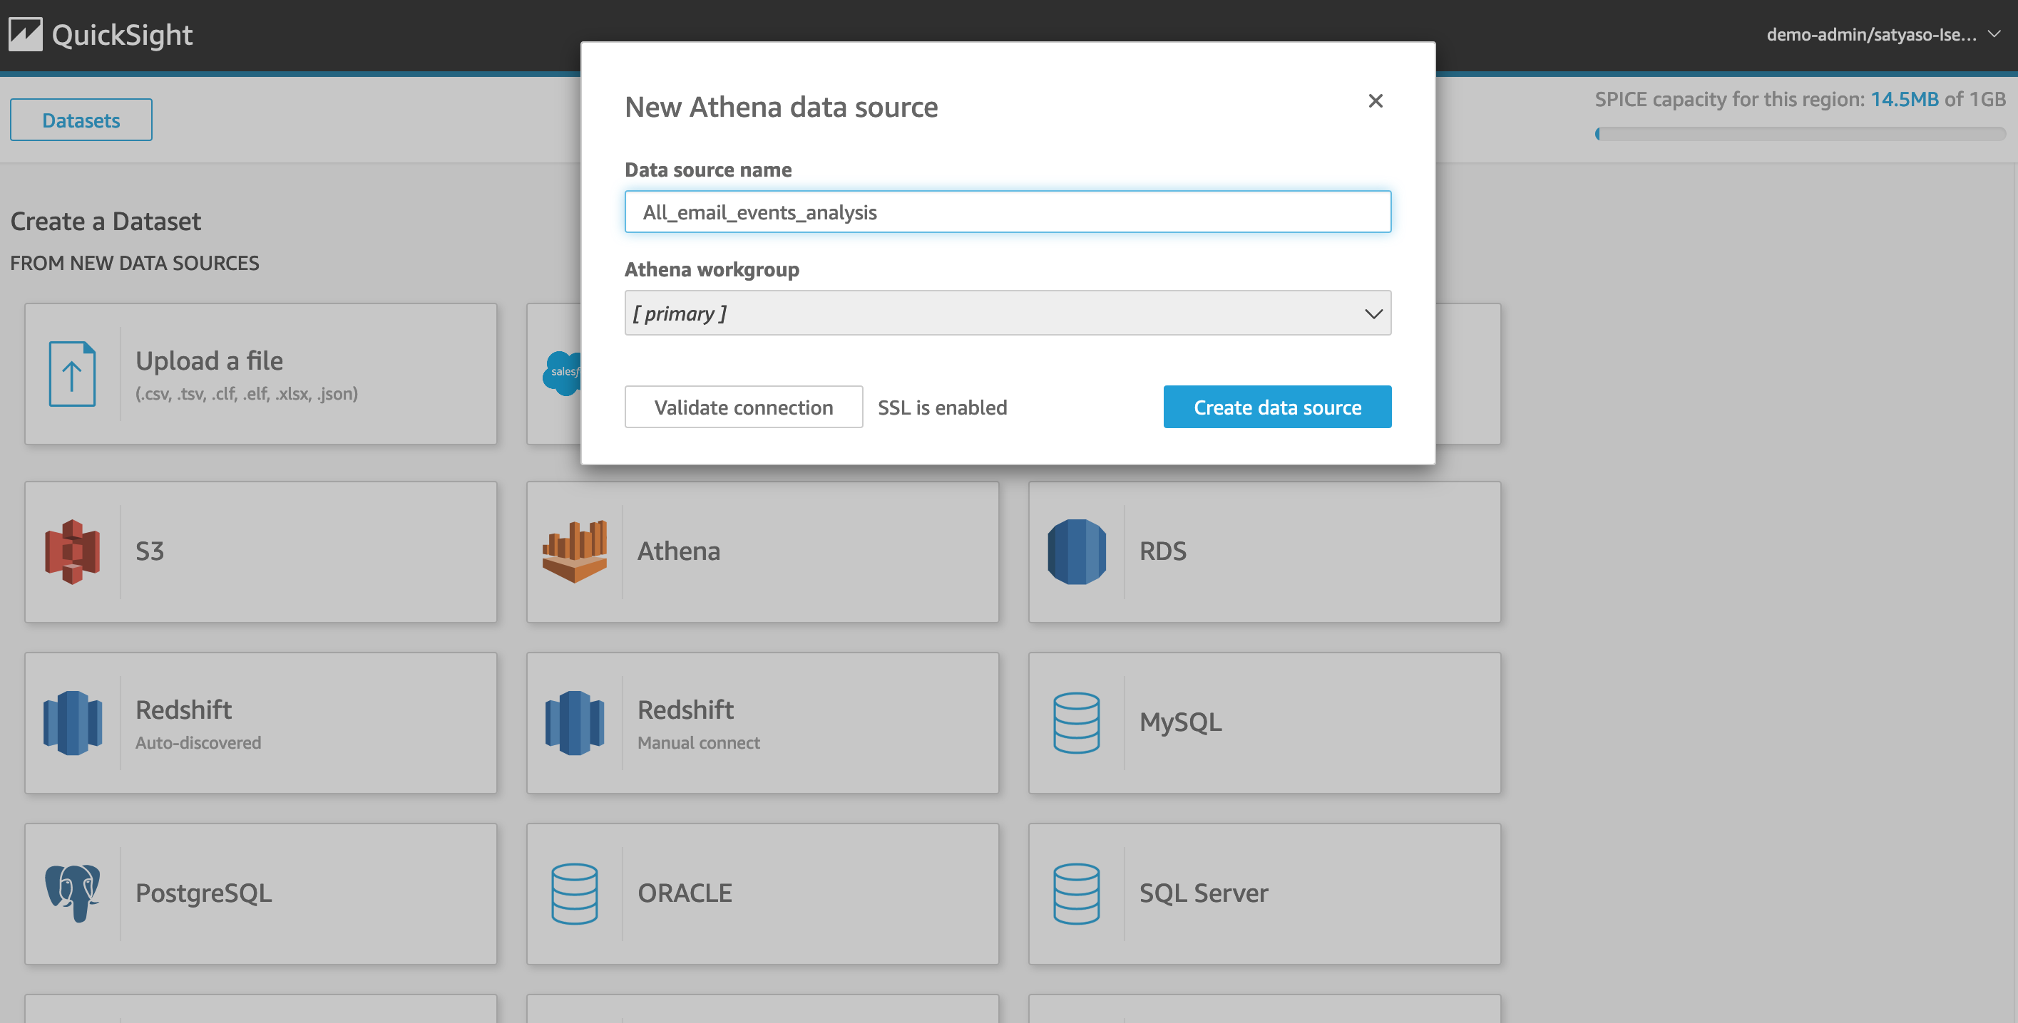

* 1. Once you create the data source Quicksight lists all the views and tables available under the specified database (in our case it is :- due_eventdb). Select the all_email_events view as data source.

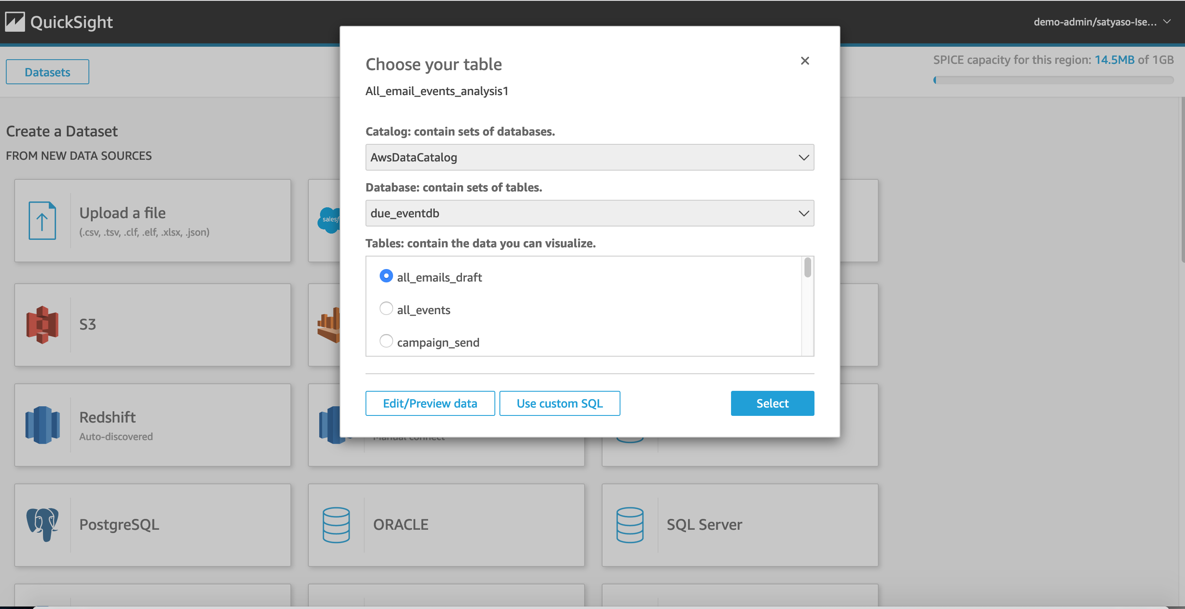

* 1. Select the event data location for analysis. There are mainly two options available which are a/ Import to Spice quicker analysis b/ Directly query your data. Please select the preferred options and then click on “visualize the data”.
  2. Import to Spice quicker analysis - [SPICE](https://docs.aws.amazon.com/quicksight/latest/user/spice.html)is the Amazon QuickSight Super-fast, Parallel, In-memory Calculation Engine. It's engineered to rapidly perform advanced calculations and serve data. In Enterprise edition, data stored in SPICE is encrypted at rest. (1 GB of storage is available for free for extra storage customer need to pay extra, please refer cost section )
  3. Directly query your data – This process enables Quicksight to query directly to the Athena or source database (In the current case it is Athena) and Quicksight will not store any data.

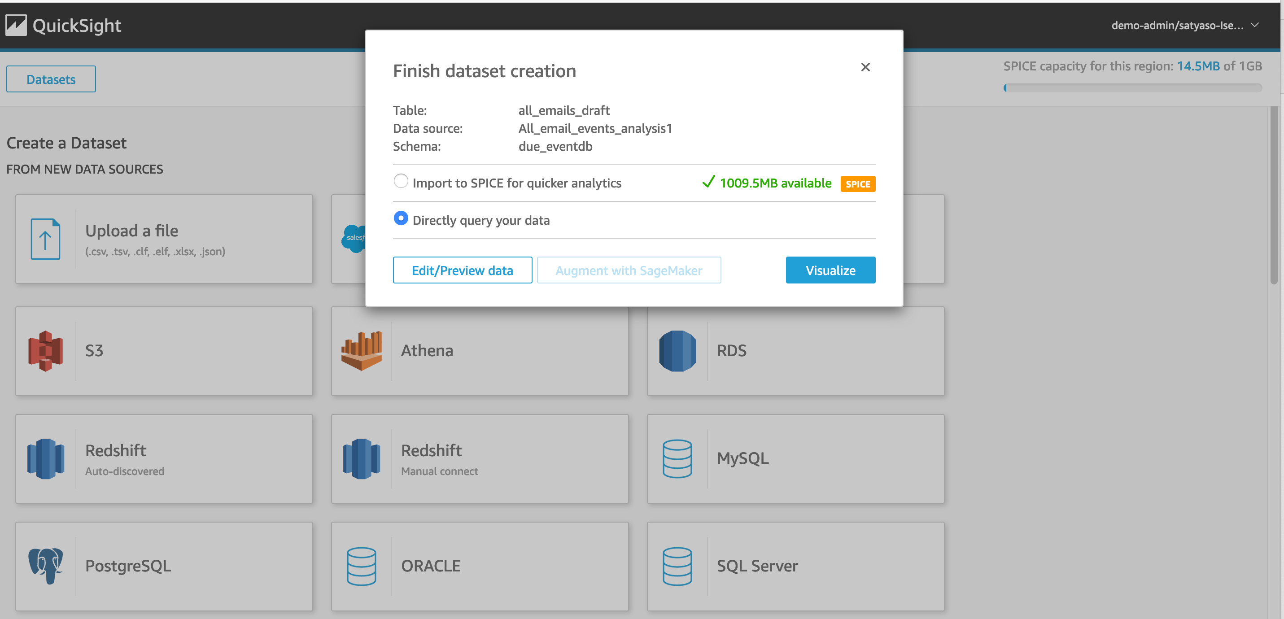

* 1. Now that you have selected a data source, you will be taken to a blank quick sight canvas (Blank analysis page) as shown in the following Image, please drag and drop what type of [visualization type](https://docs.aws.amazon.com/quicksight/latest/user/working-with-visual-types.html) you need to visualize onto the auto graph pane. Please note that Amazon QuickSight is a Busines intelligence platform, so customer are free to choose the desired visualization types to observe the individual engagement events.

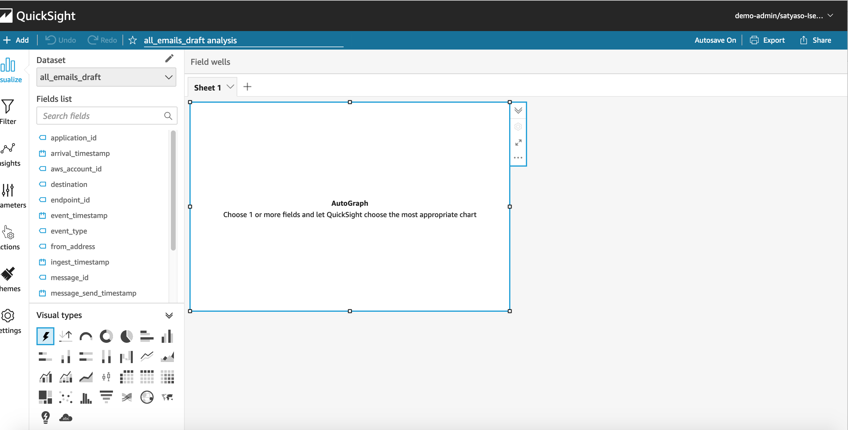 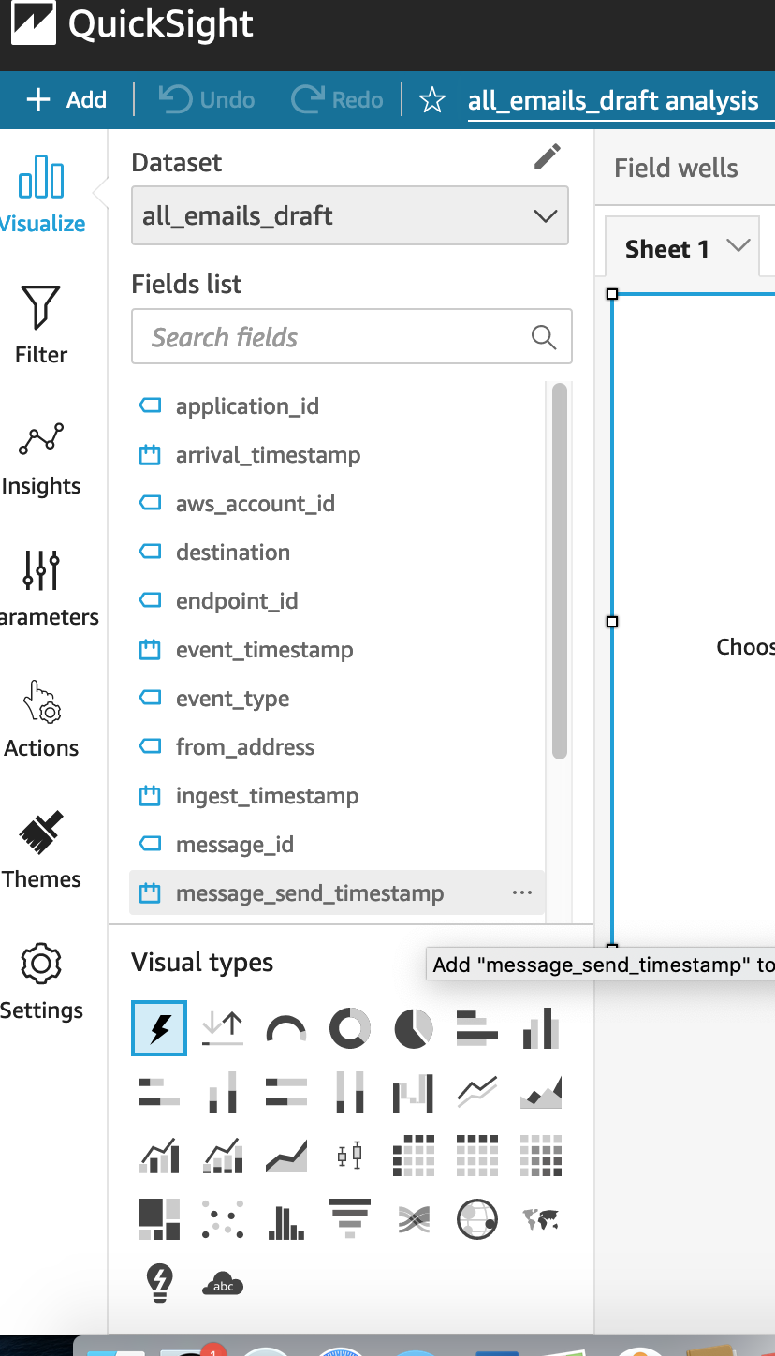

* 1. As part of this blog, we have displayed how to create some simple analysis graphs to visualize the engagement events.
  2. As an initial step please Select tabular Visualization as shown in the Image.

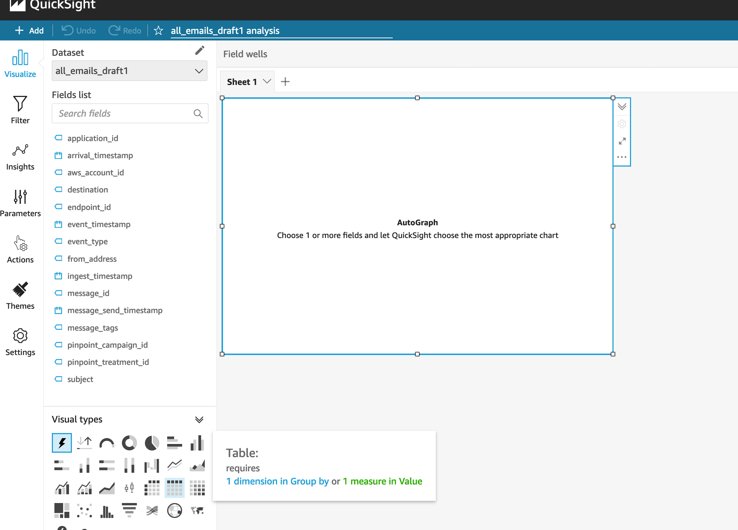 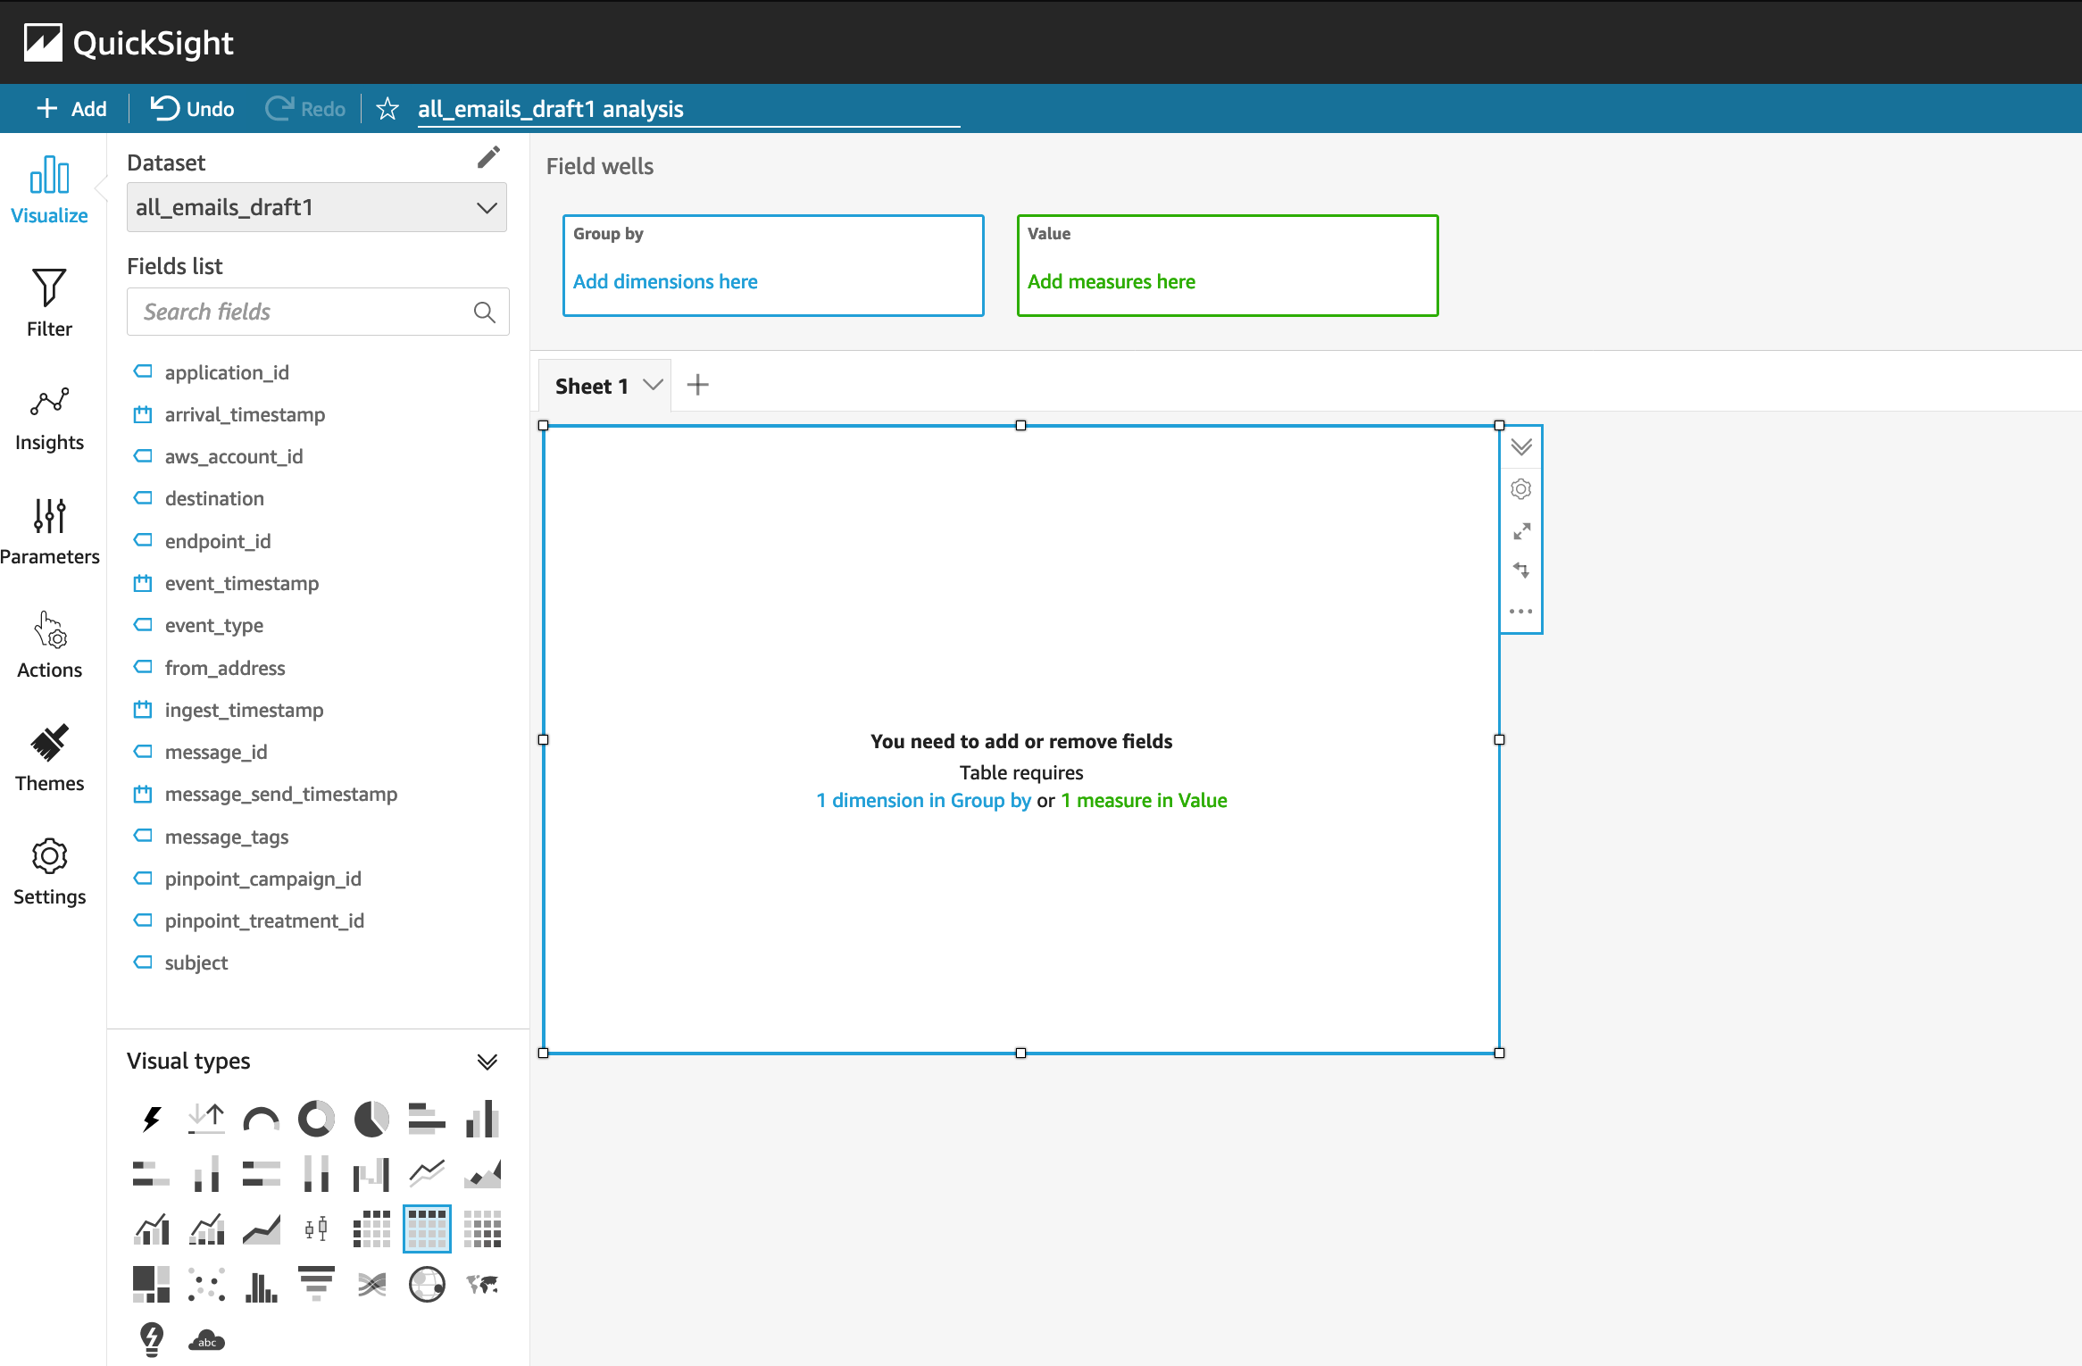

* 1. Select all the event dimensions that you want to put it as part of the Table in X axis. Amazon Quicksight table can be extended to show as many as tables columns, this completely depends upon the business requirement how much data marketers want to visualize.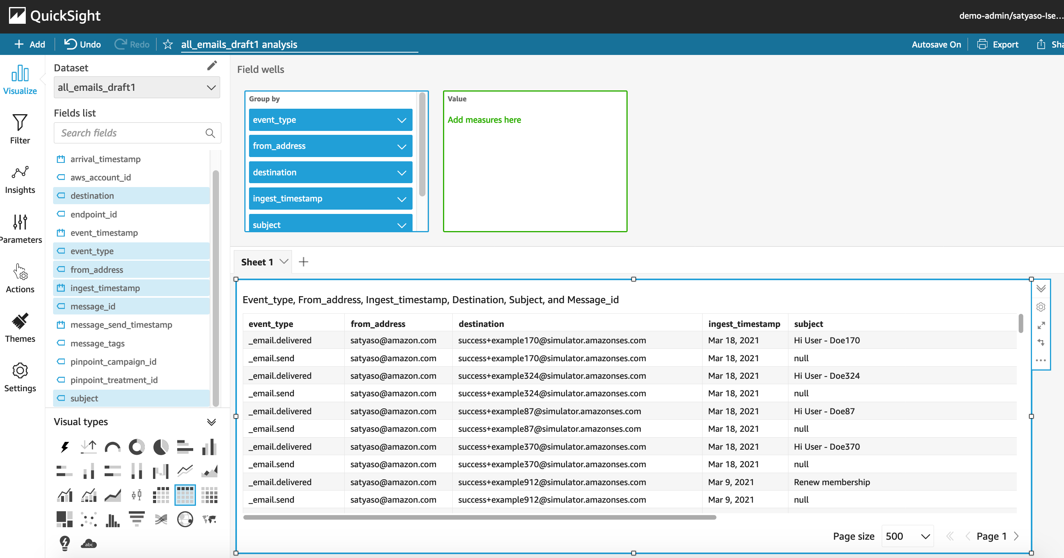
  2. [Further filtering](https://docs.aws.amazon.com/quicksight/latest/user/add-a-filter.html) on the table can be done using Quicksight filters, you can apply the filter on specific granular values to enable further filtering. For Eg – If you want to apply filtering on the destination email Id then 1/Select the filter from left hand menu 2/Add destination field as the filtering criterion 3/ Tick on the destination field you are trying to filter or search for the Destination email ID that 4/ All the result in the table gets further filtered as per the filter criterion

1/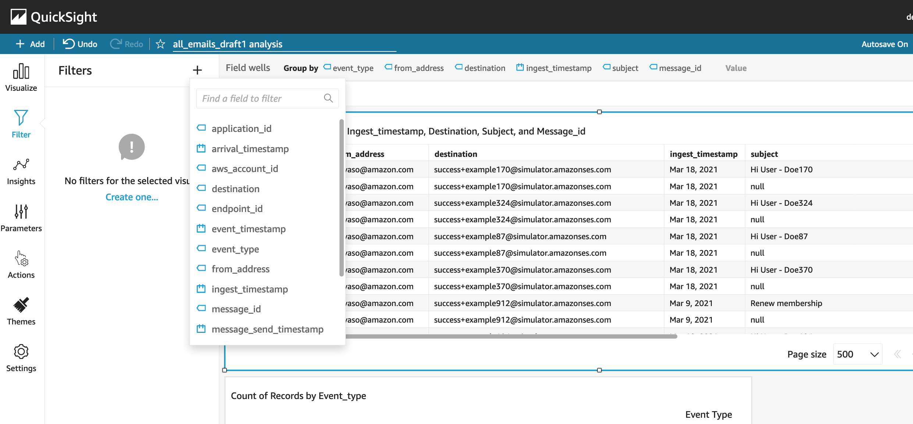 2/ 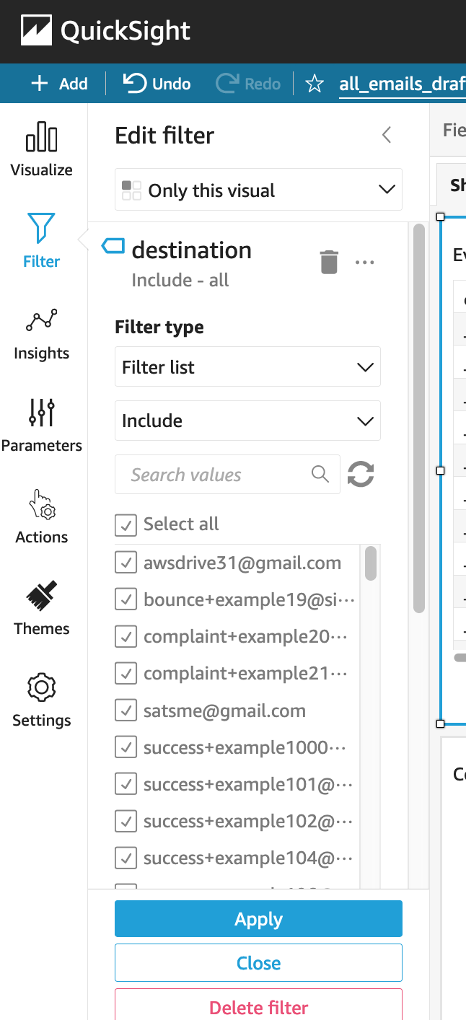

3/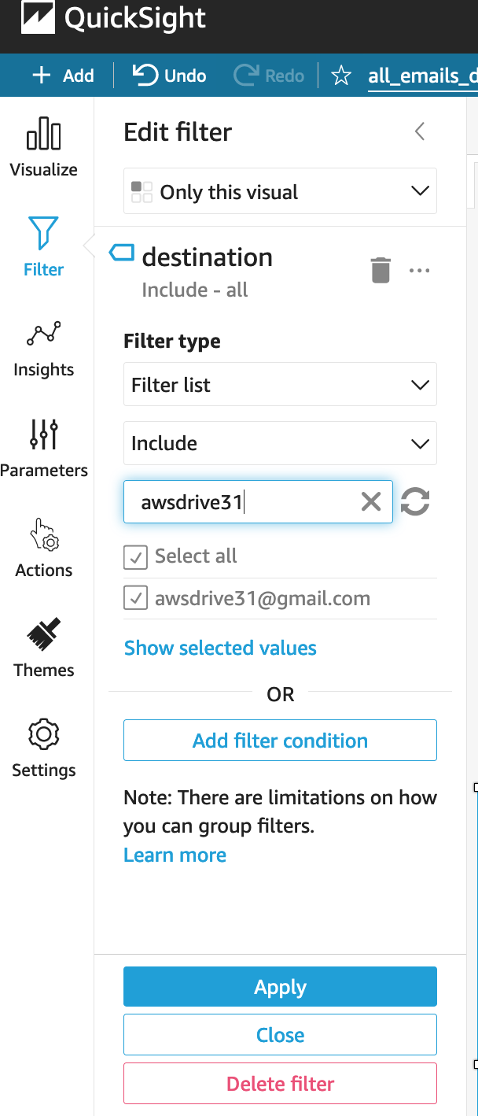 4/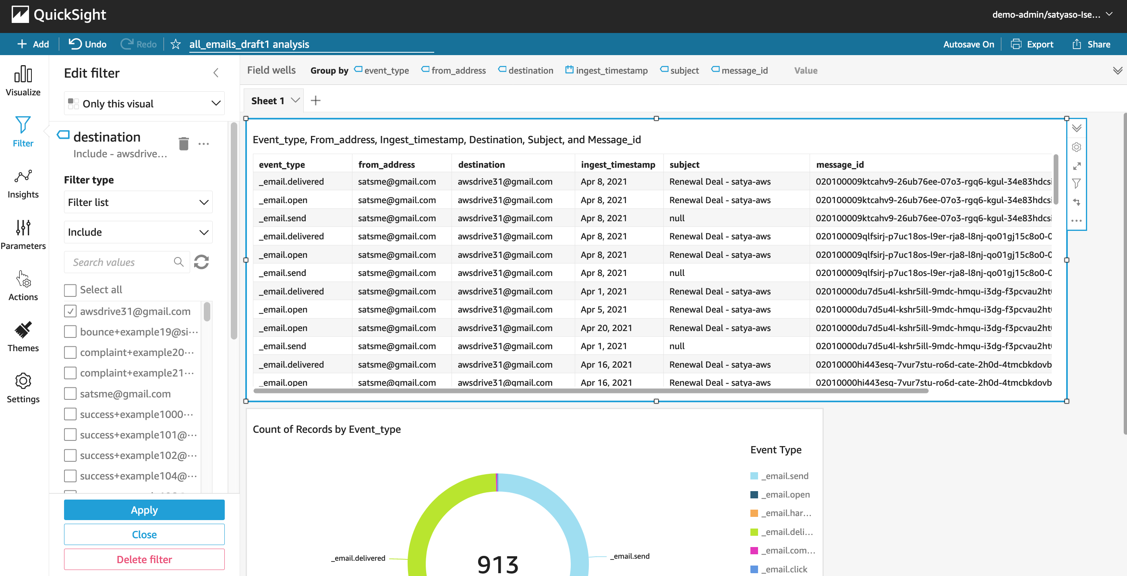

* 1. As a next step please add another visual from top left Add -> Add Visual, then select the **Donut Chart** from Visual types pane. Donut charts are always used for displaying aggregation.

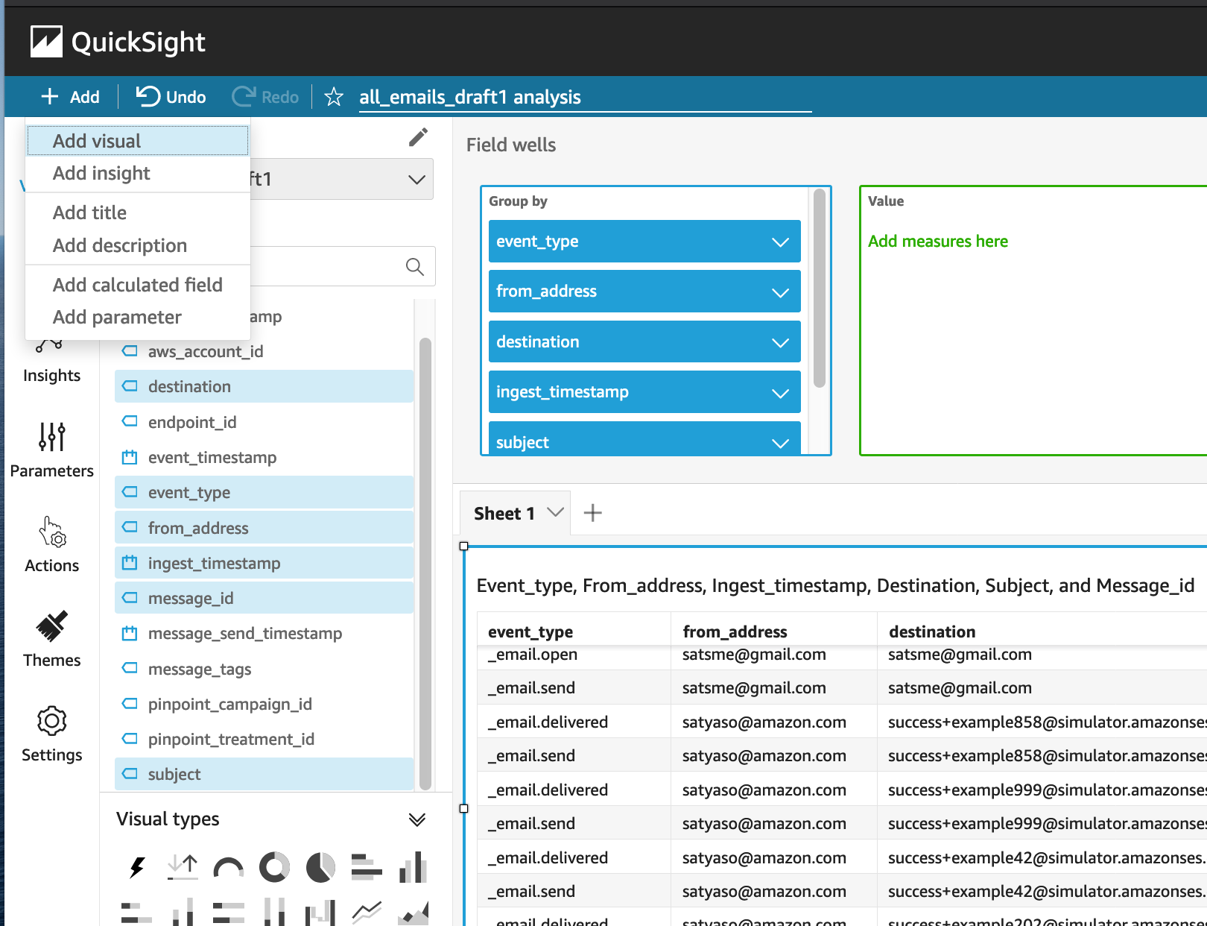

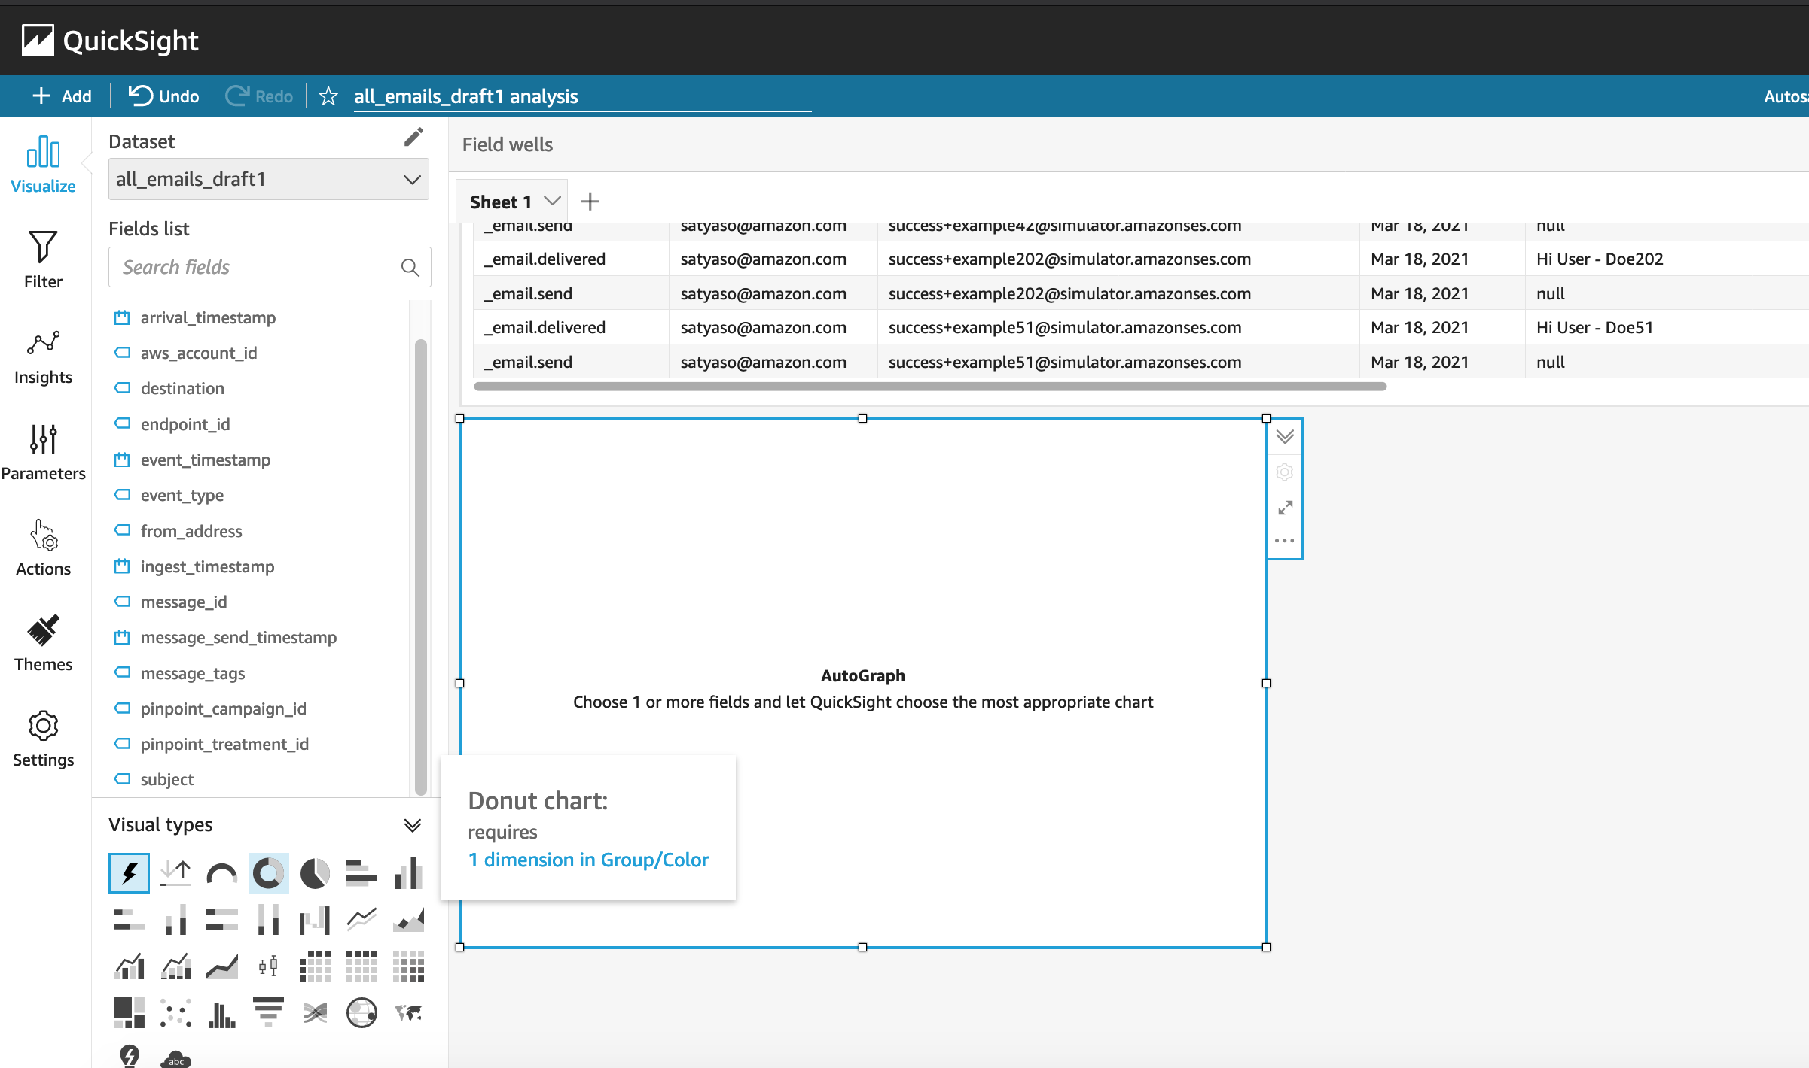

* 1. Then select the “event_type” as the Group to visualize the aggregated events, this helps marketers/business users to figure out how many email events occurred and what are the aggregated success ratio, click ratio, complain ratio or bounce ratio etc for the emails/Campaign that’s sent to end users.

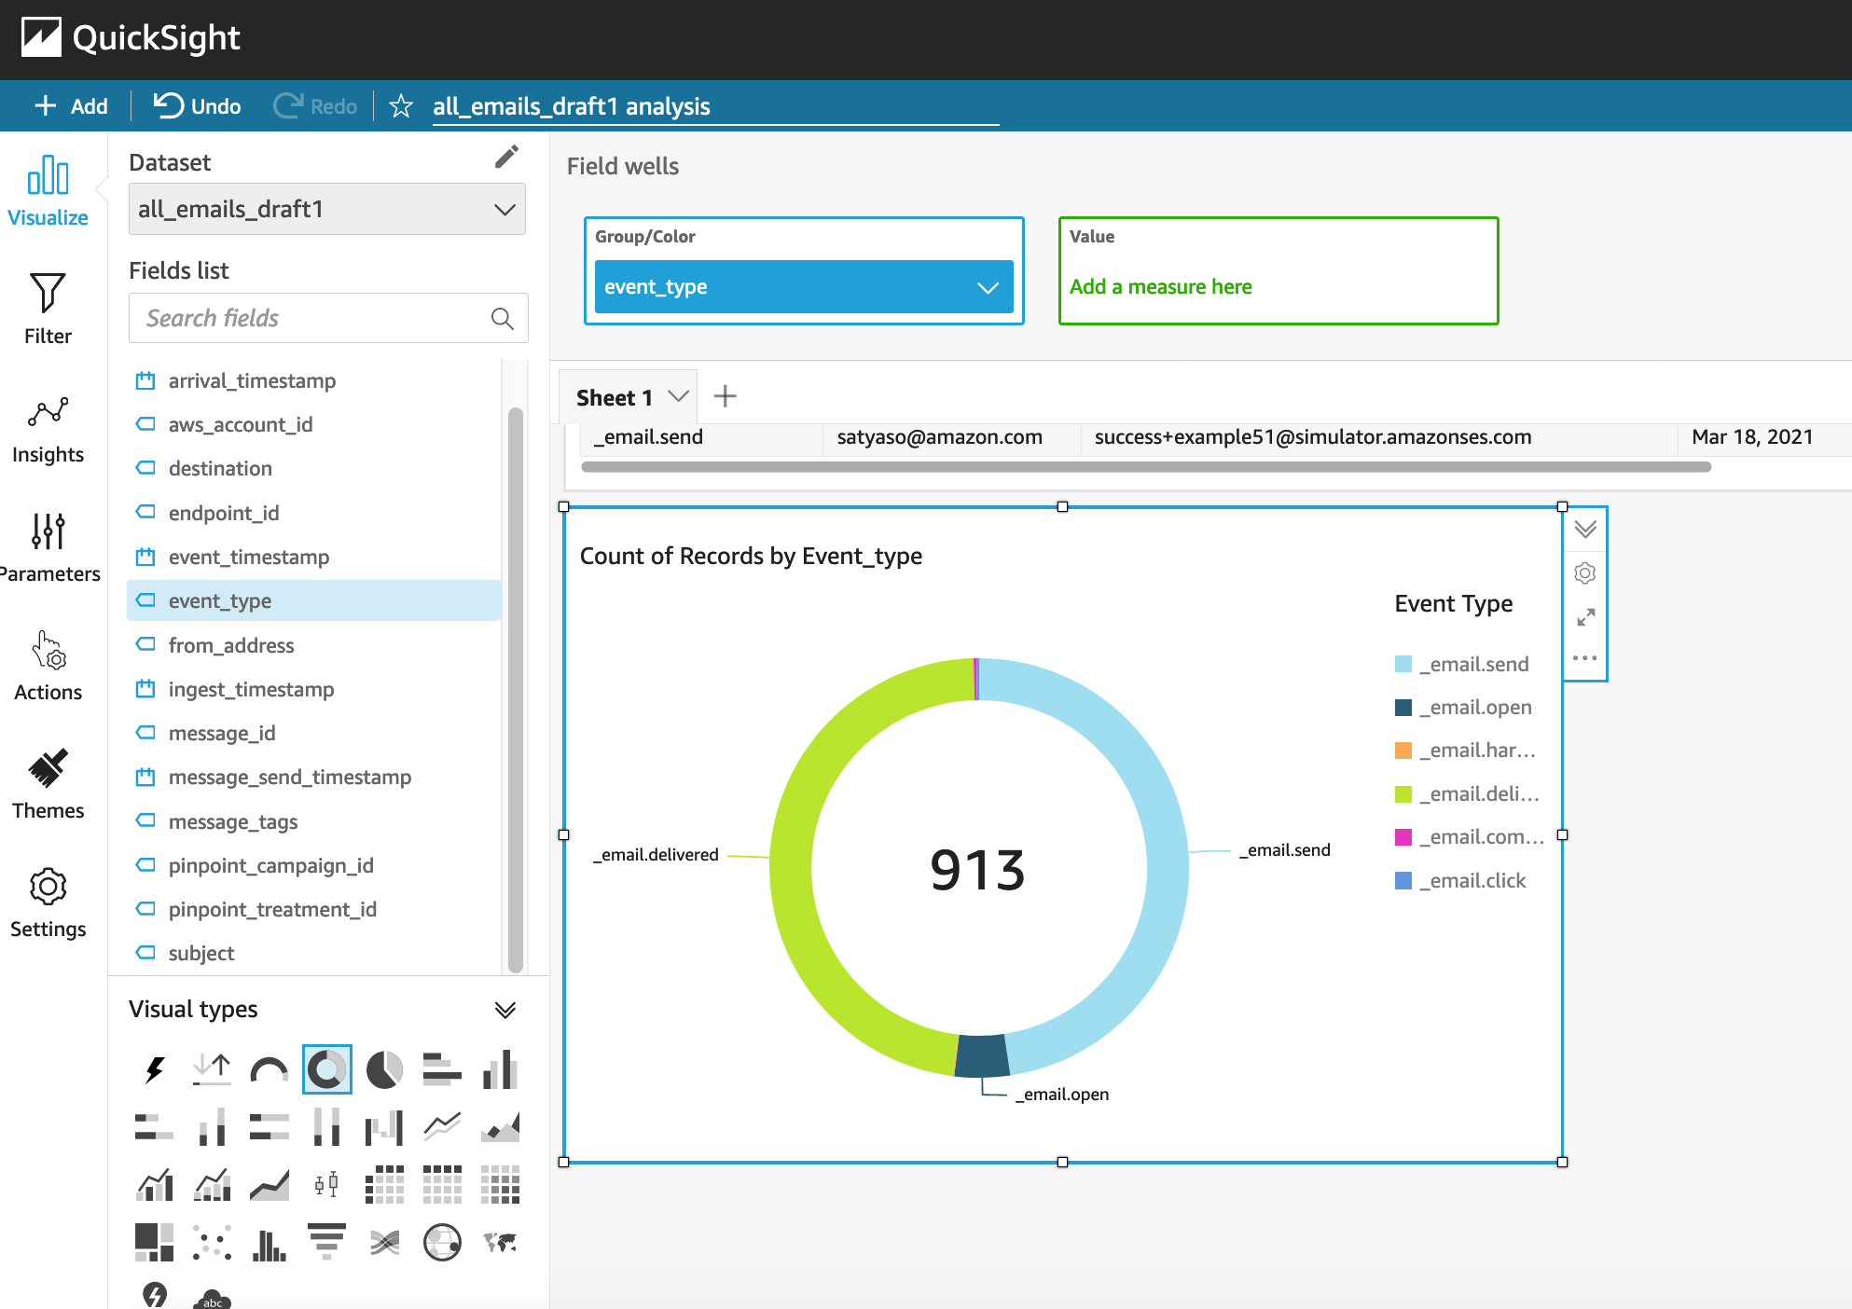

* 1. To create a Quicksight dashboards from the Quicksight analysis click Share menu option at the top right corner then select publish dashboard”. Provide required dashboard name while publishing the dashboard”. Same dashboard can be shared with multiple audiences in the Organization.

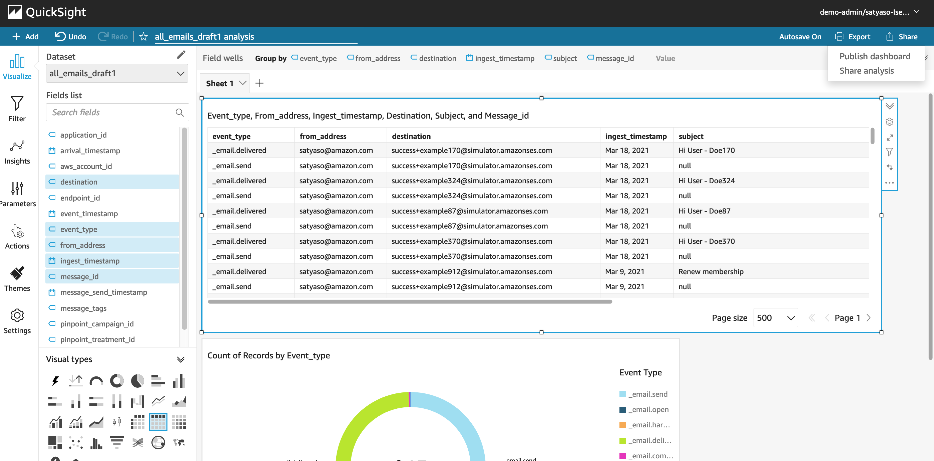

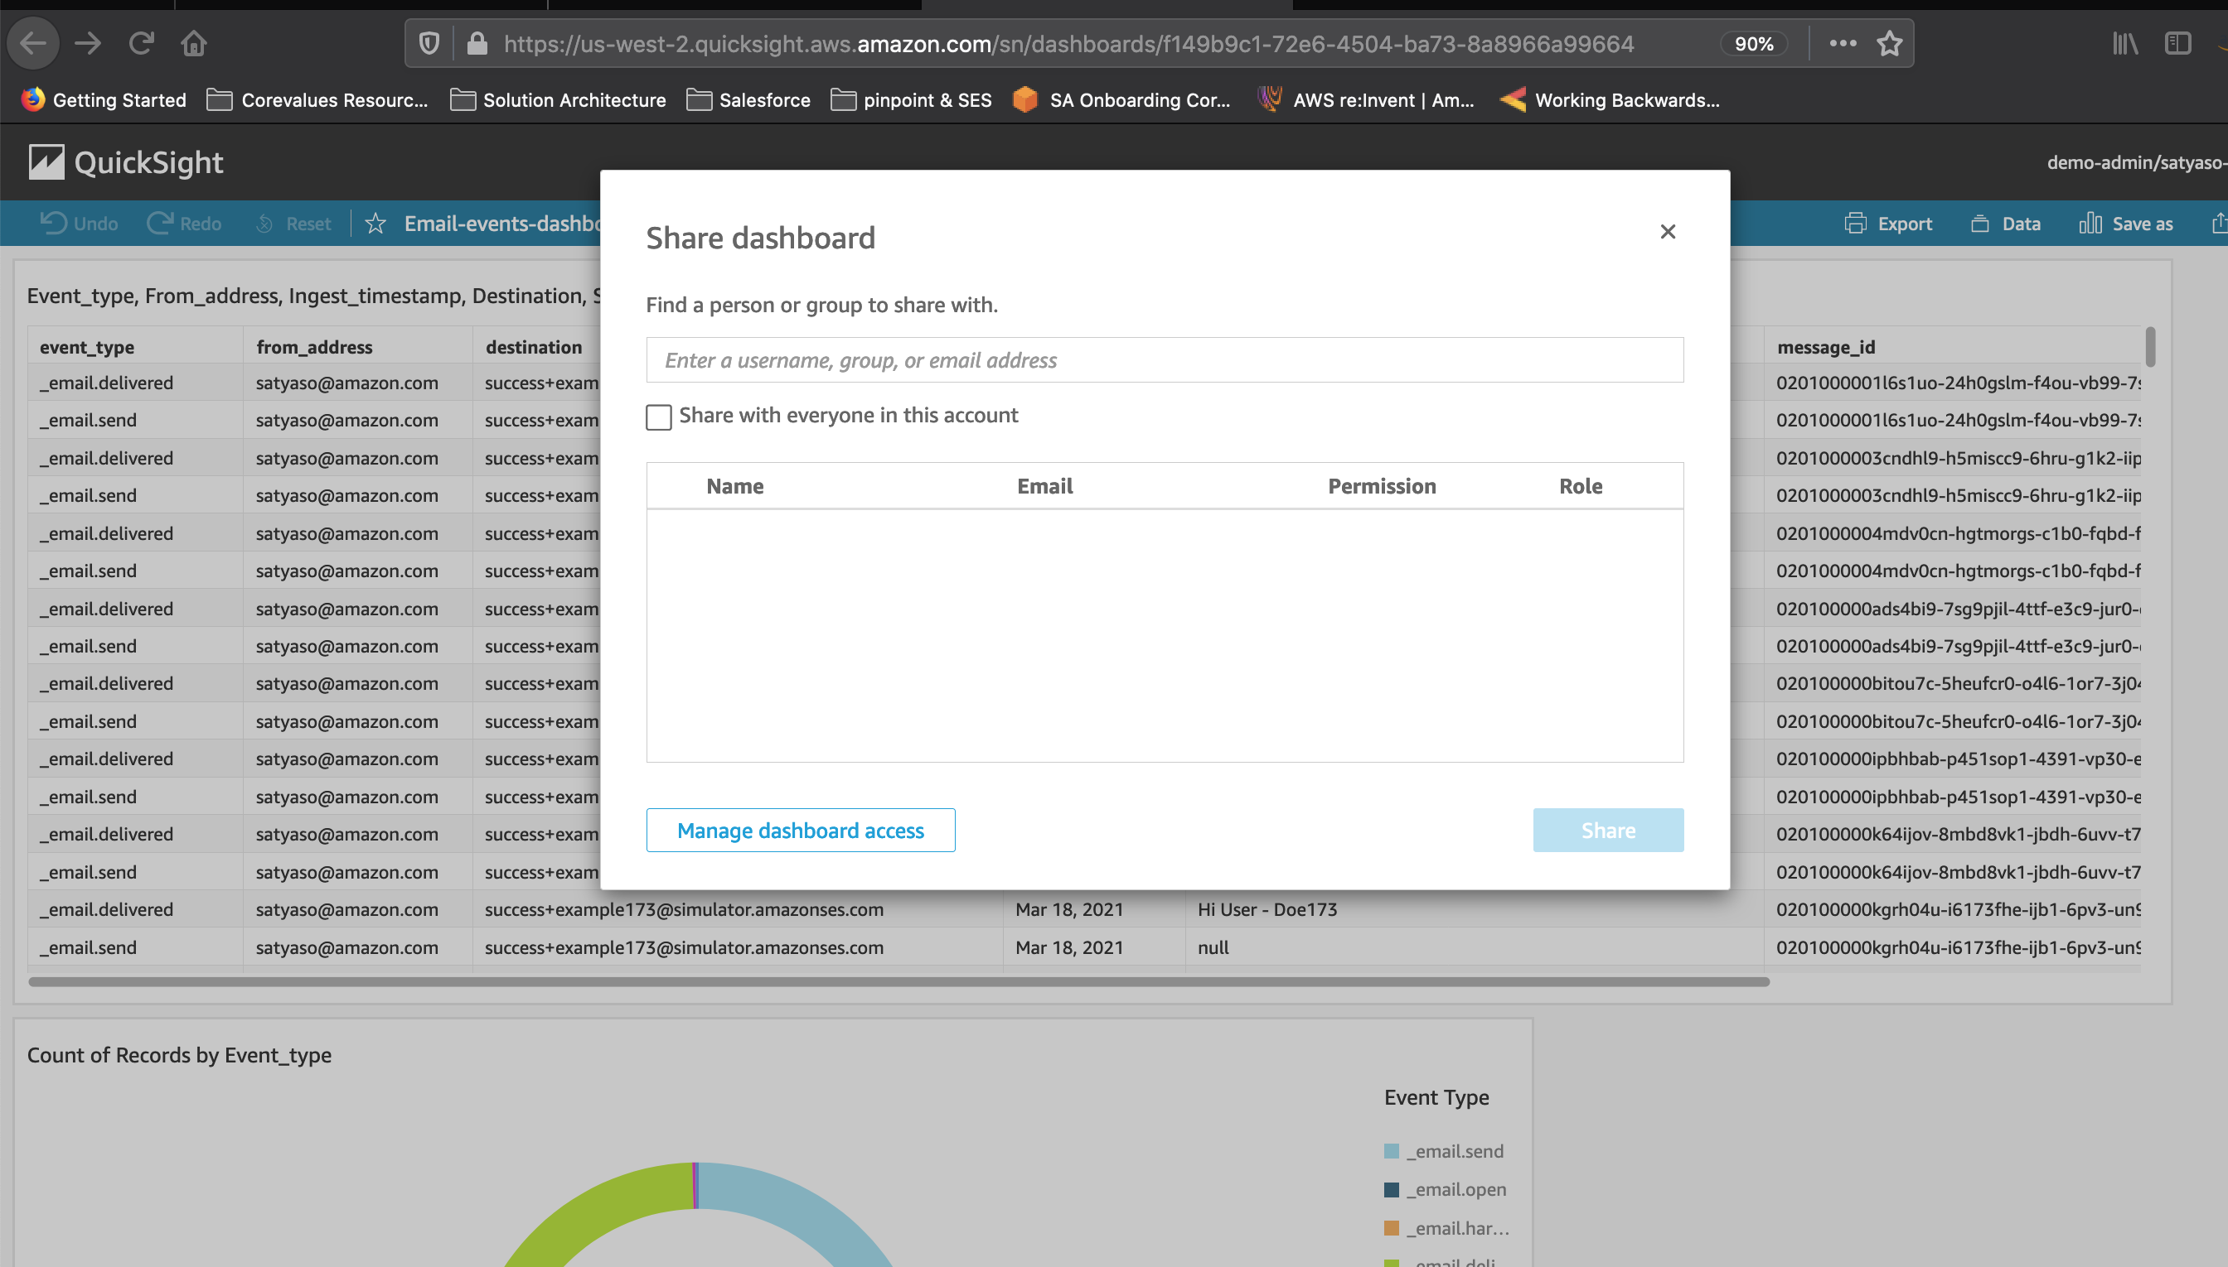

* 1. Following is the final version of the dashboard. As mentioned above Quicksight dashboards can be shared with other stakeholders and also complete dashboard can be exported as excel sheet.

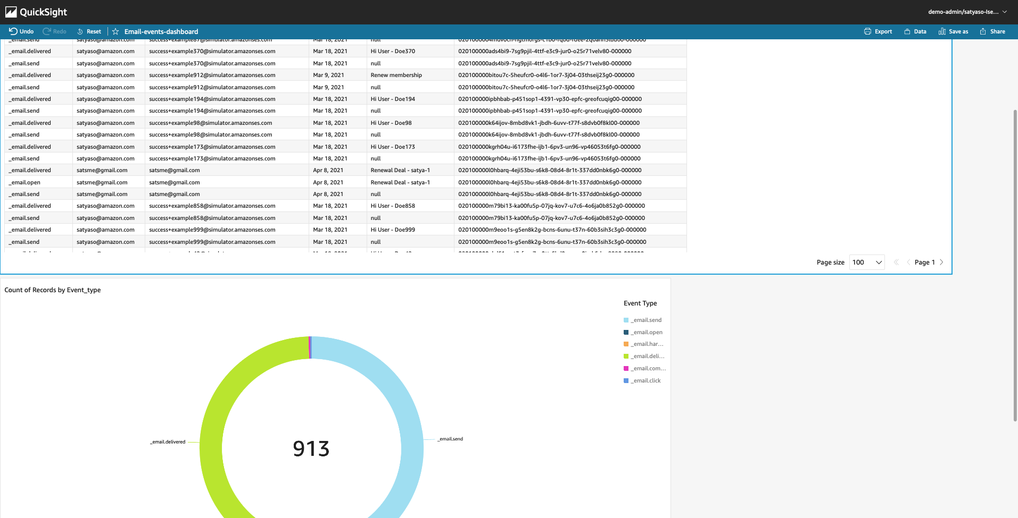

1. **SMS Events-** 
   1. As shown above SMS events can be analyzed using Quicksight and dash boards can be created out of the analysis. Please repat the steps from 6.1 to 6.14. Following is a sample SMS dashboard.

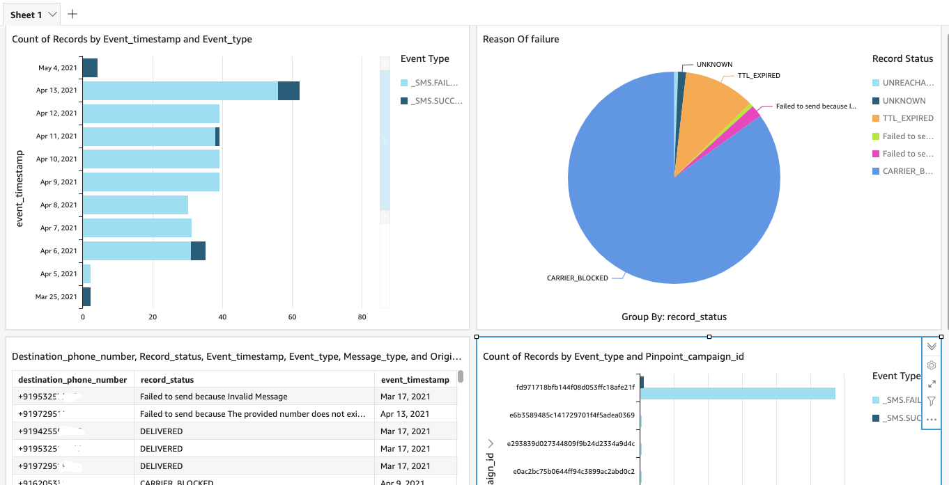

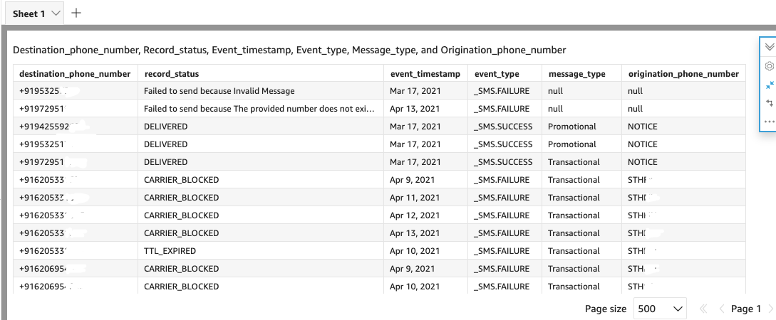

1. **Custom Events-** 
   1. After you integrate your application (app) with Amazon Pinpoint, Amazon Pinpoint can stream [event data](https://docs.aws.amazon.com/pinpoint/latest/developerguide/event-streams-data-app.html) about user activity, different type custom events, and message deliveries for the app. Eg :- Session.start, Product_page_view, _session.stop etc. Do repeat steps 6.1 to 6.14 create a Customer event dashboards.

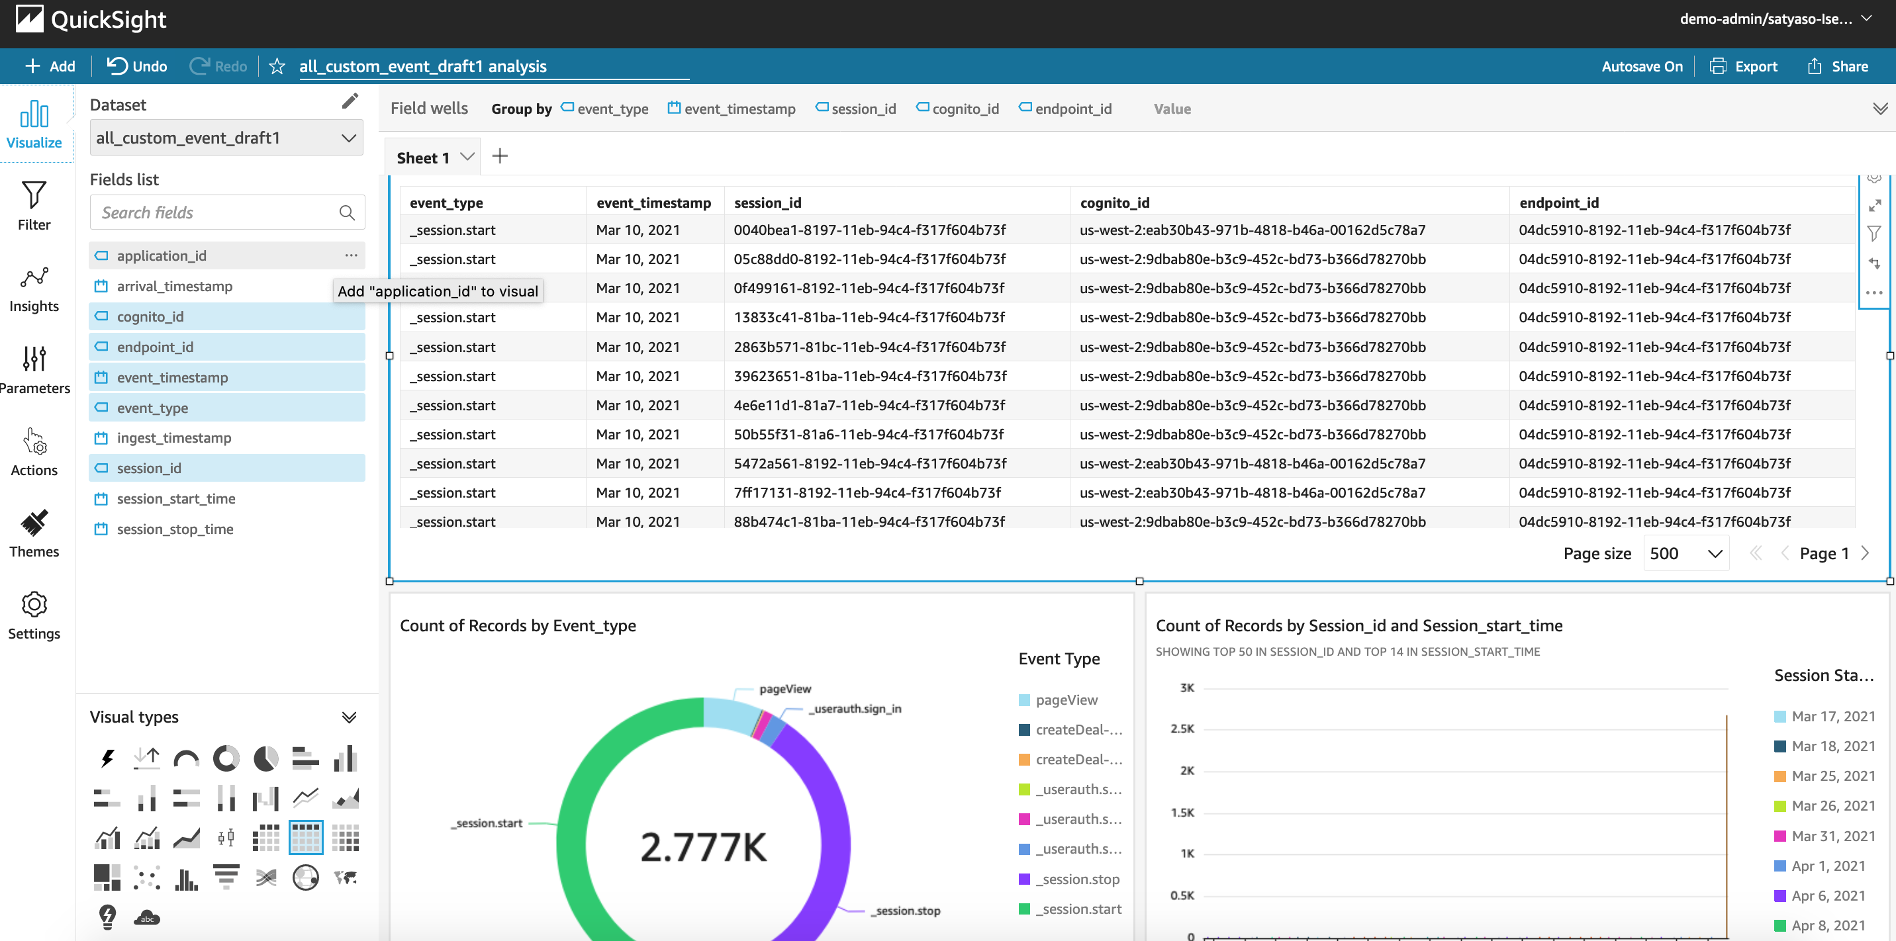

1. **Journey events**

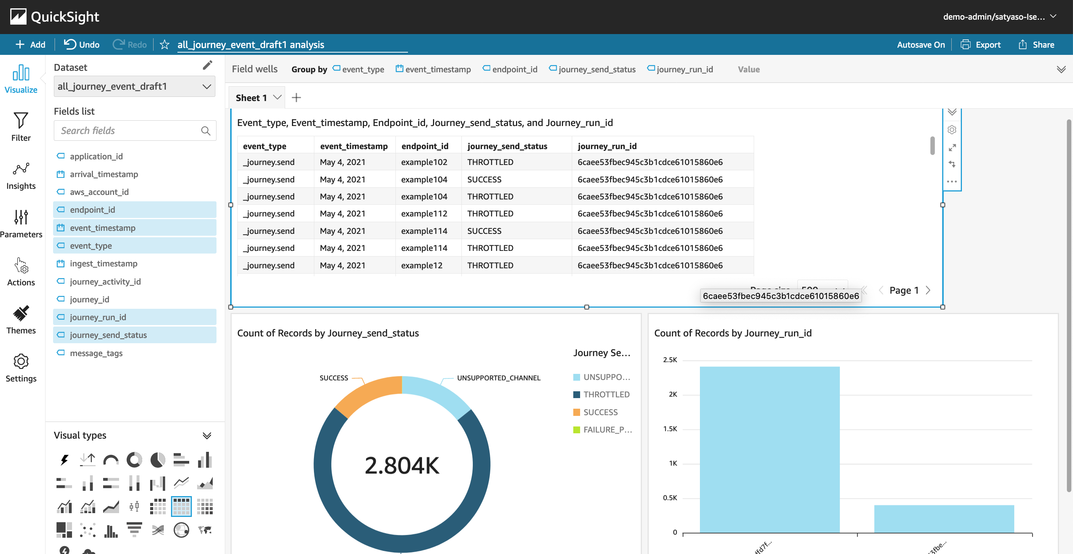

1. **Campaign events**

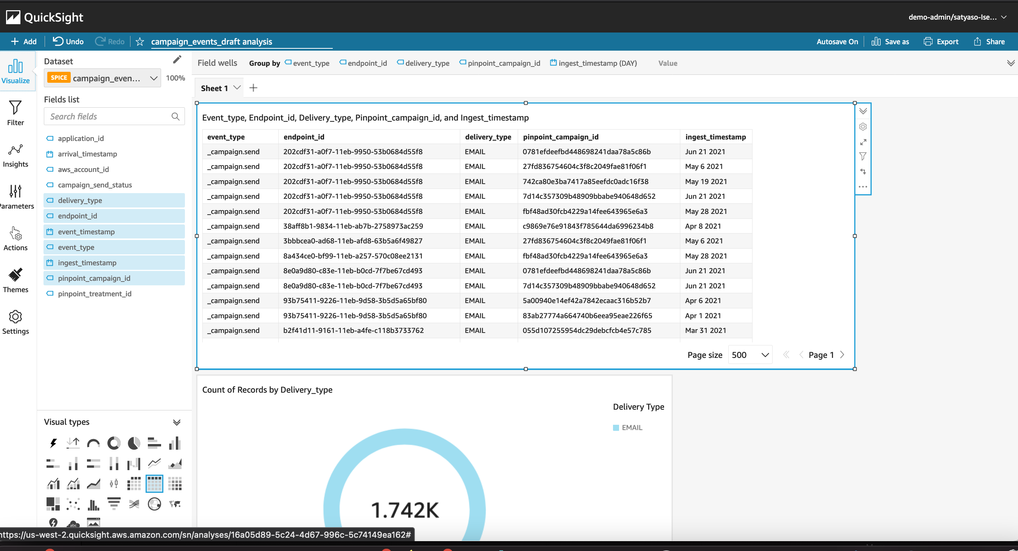

## Conclusion

In this blog post, I have demonstrated how marketers, business users, and business analysts can utilize Amazon Quicksight dashboards to evaluate and exploit user engagement data from Amazon SES and Pinpoint event streams. Customers can also utilize this solution to understand how Amazon Pinpoint campaigns lead to business conversions, in addition to analyzing multi-channel communication metrics at the individual user level.

## Next steps

This blog's personas are both tech team and marketing analyst team, as it involves a code deployment to create very simple Athena views, as well as the steps to create an Amazon Quicksight dashboard to analyze Amazon SES and Amazon Pinpoint engagement events at the individual user level.

Customers can then design their own Amazon Quicksight dashboards to display compute the conversion ratio in real time and propensity trends by combining campaign events with app-level events such as purchase conversions, order placement, and so on. AWS account team and service Specialist members can assist customers who wish to learn more about Amazon Pinpoint event analytics and which all Amazon Quicksight graphs are ideal for their use case

## Extending the solution

You can download the AWS Cloudformation templates, code, and scripts for this solution from our GitHub repository [< link>](https://github.com/Satya-Git3105/Due-events-dashboard) and modify it to fit your needs.

## Appendix -1

**Setup Amazon Quicksight :**

This step will help in setup Amazon Qucksight for first time.

Log into the console in the Cost Optimization account as an IAM user with the required permissions, go to the Amazon Quicksight console

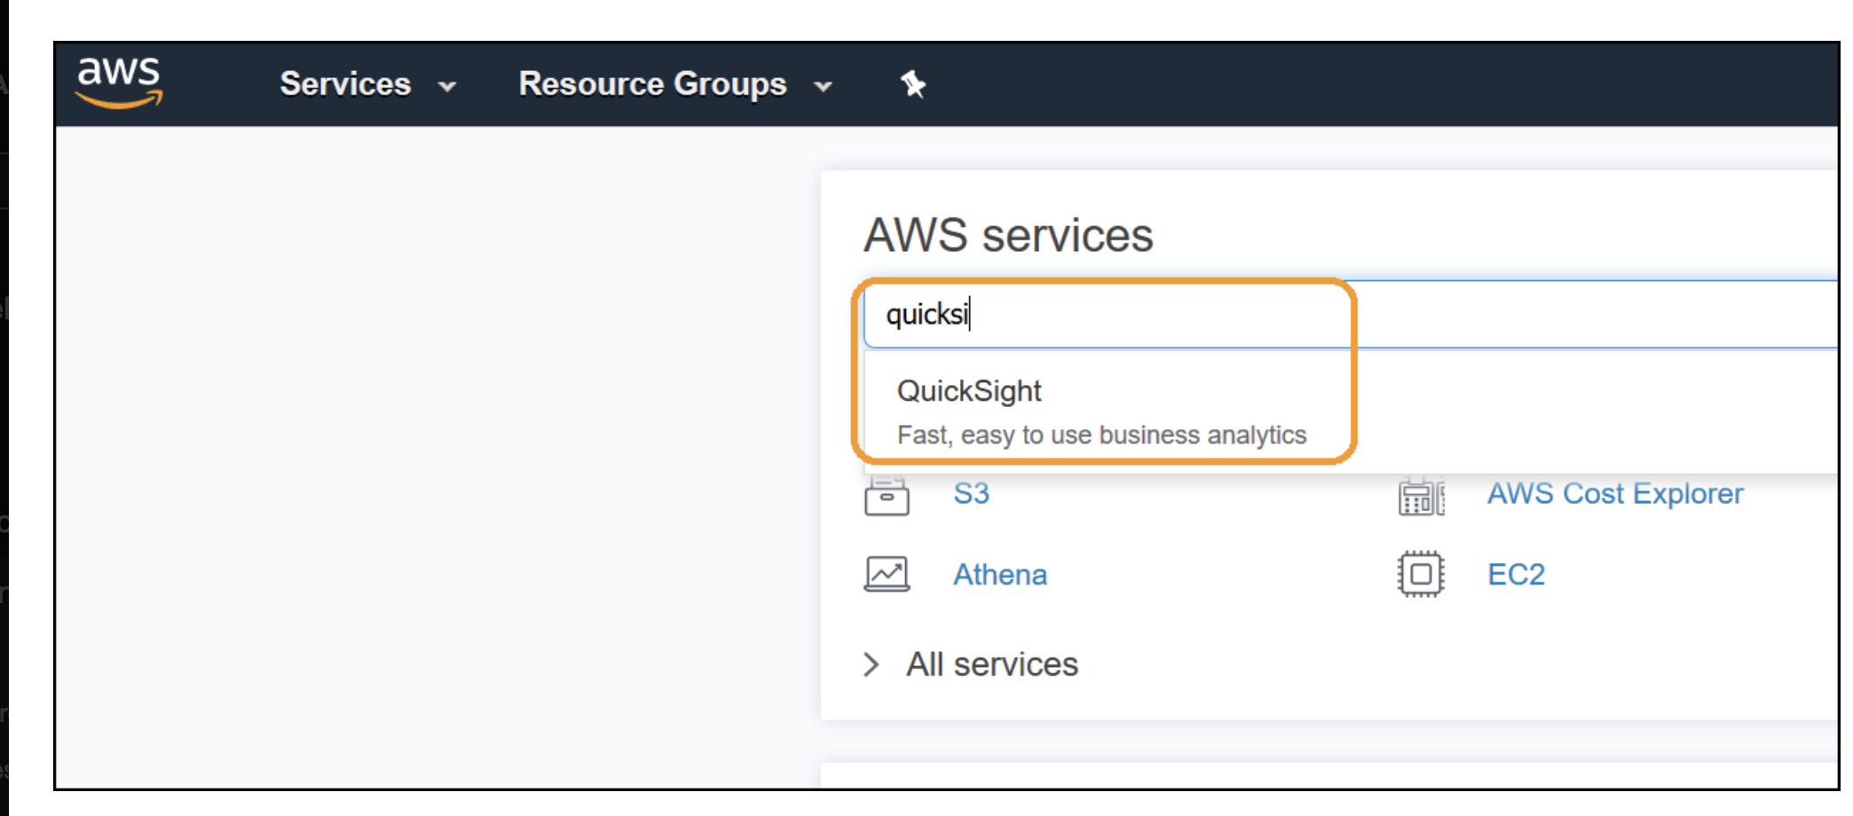

If you haven’t used QuickSight before click on **Sign up for QuickSight**, otherwise skip this step and proceed to **Setup QuickSight IAM Policy** below

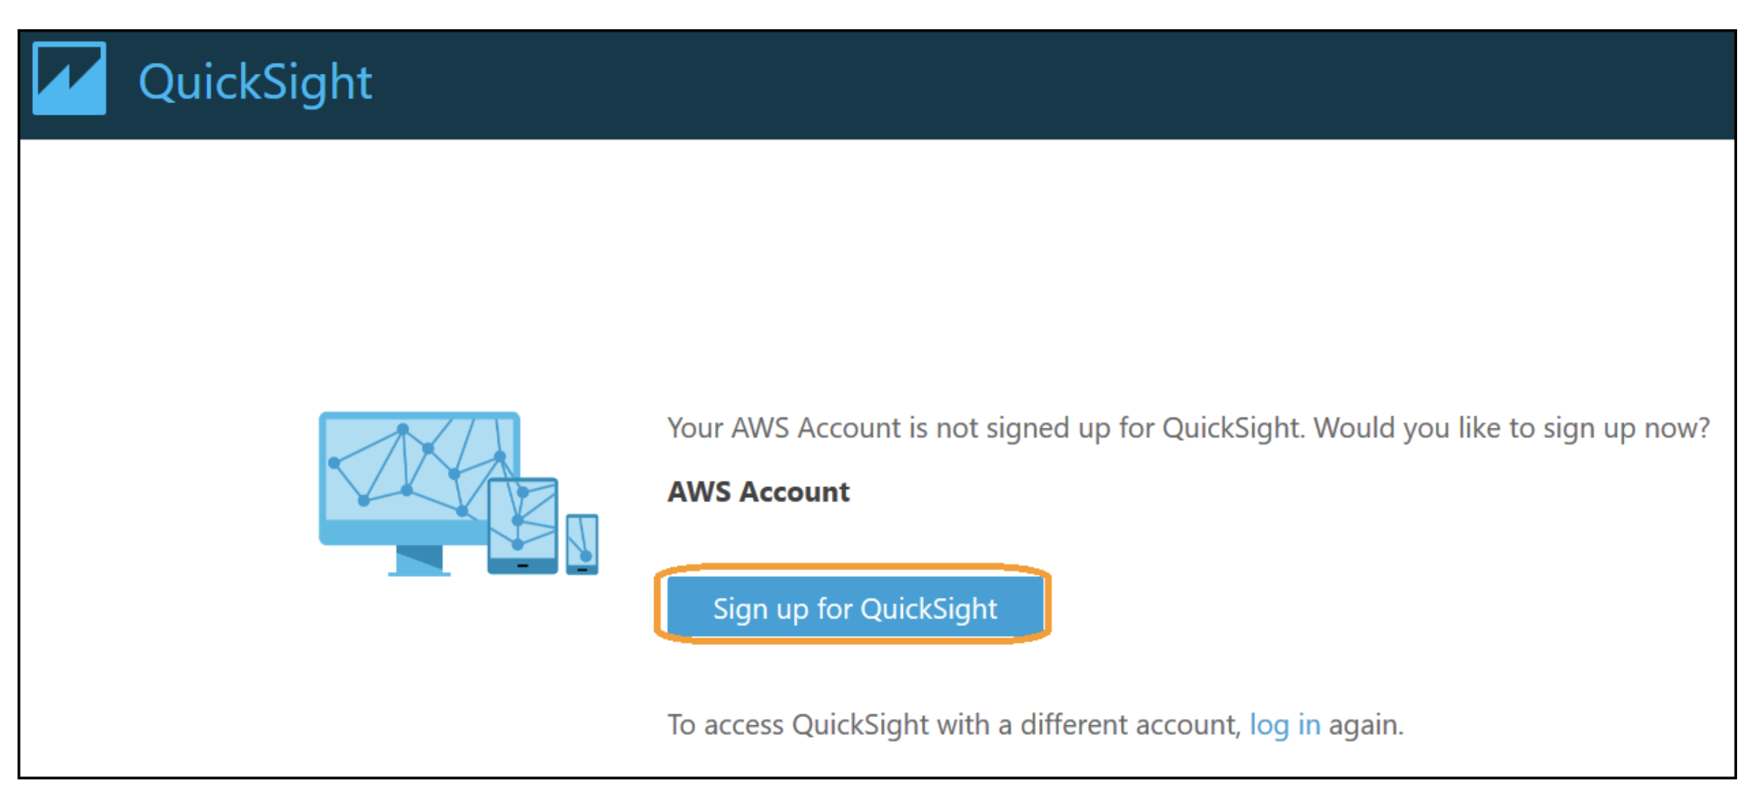

Select the **Standard/Enterprise** edition as per your need, and click **Continue**:

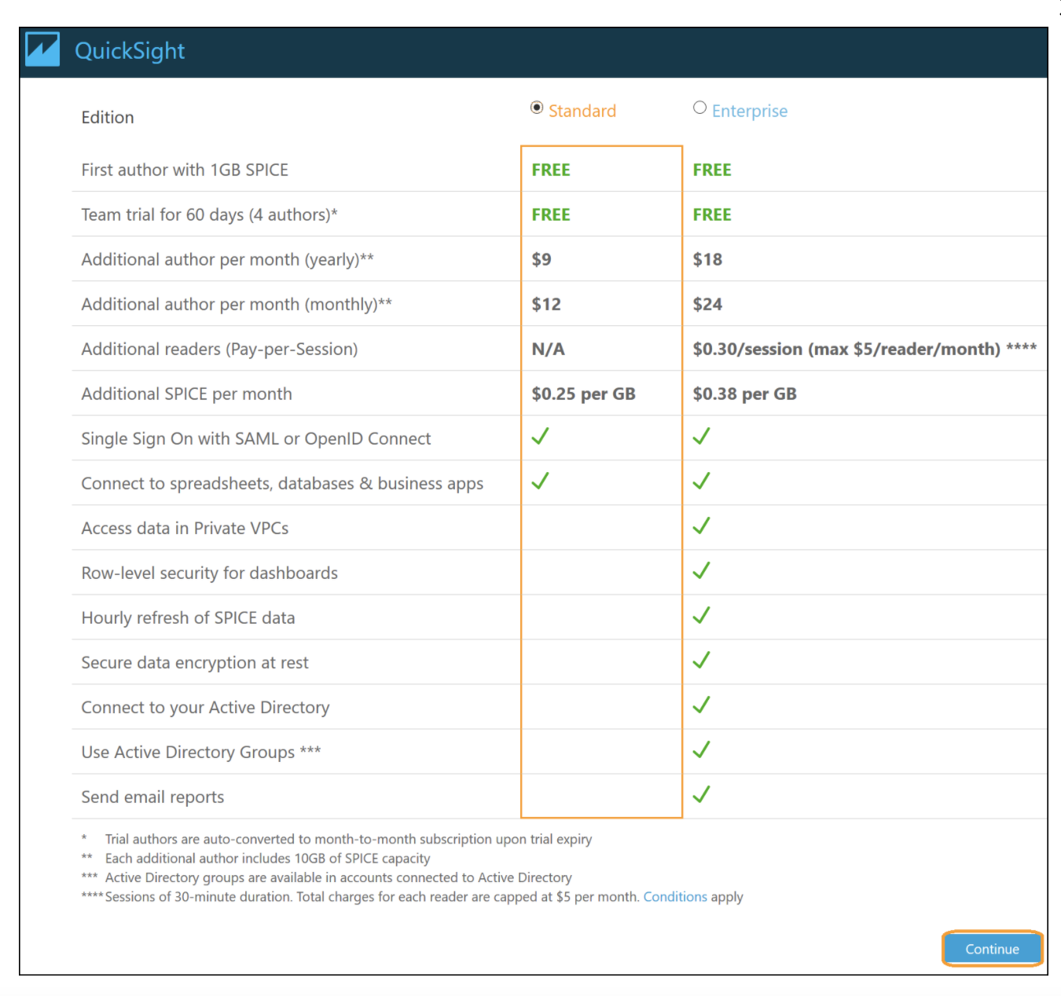

Select the **region** which should be the same as your CUR file source, Enter your **QuickSight account name**, **Notification email address**, select **Amazon Athena** and click **Choose S3 buckets**:

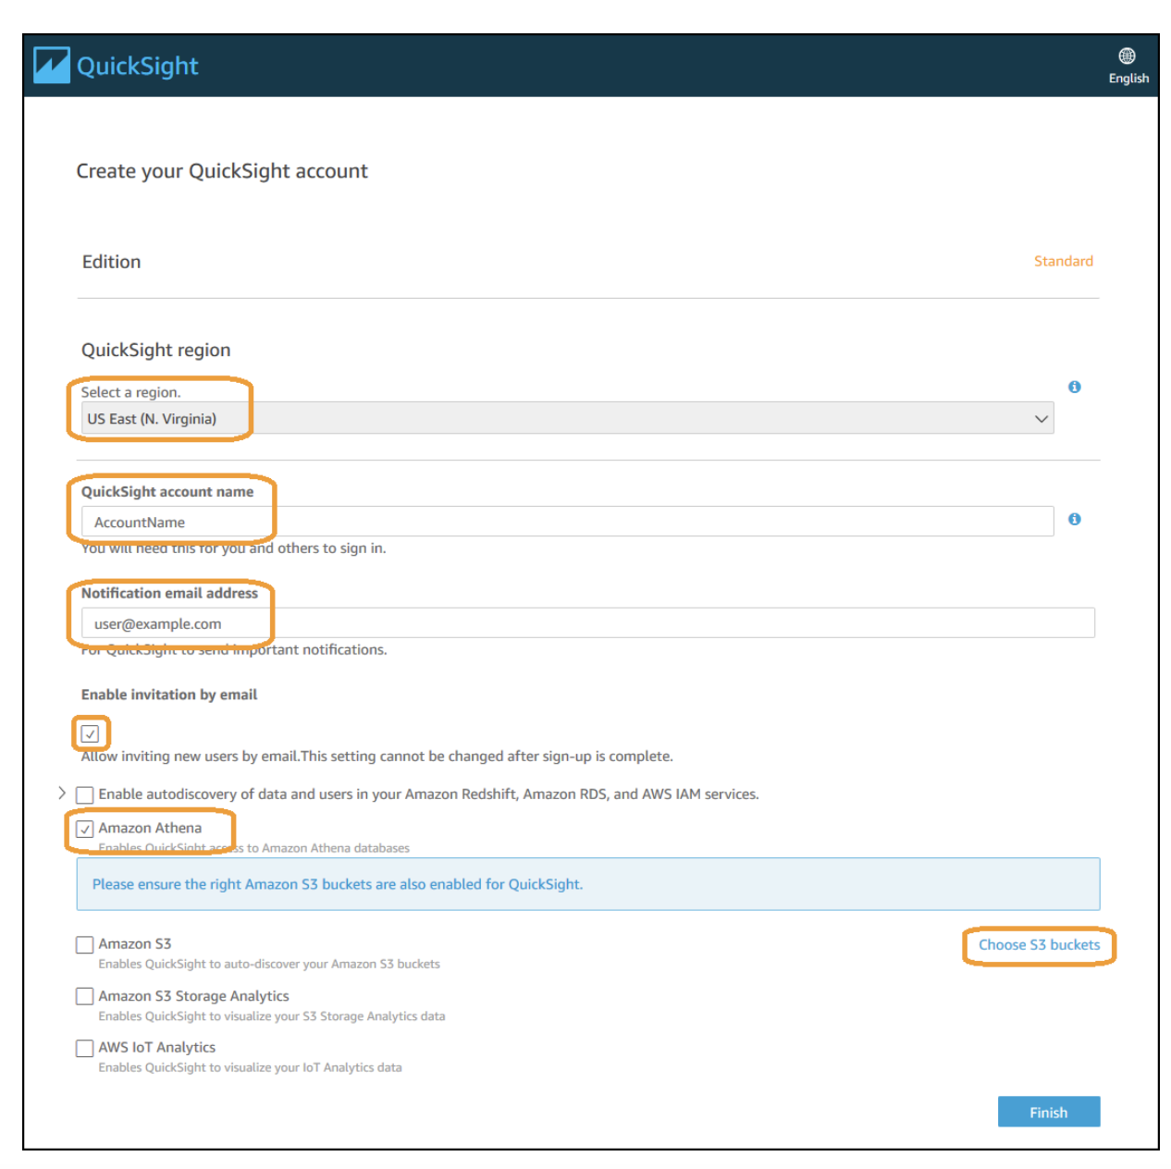

Select **S3 Buckets You Can Access Across AWS**, under **Use a different bucket** enter the **CUR bucket name**, click **Add S3 bucket** and click **Finish**:

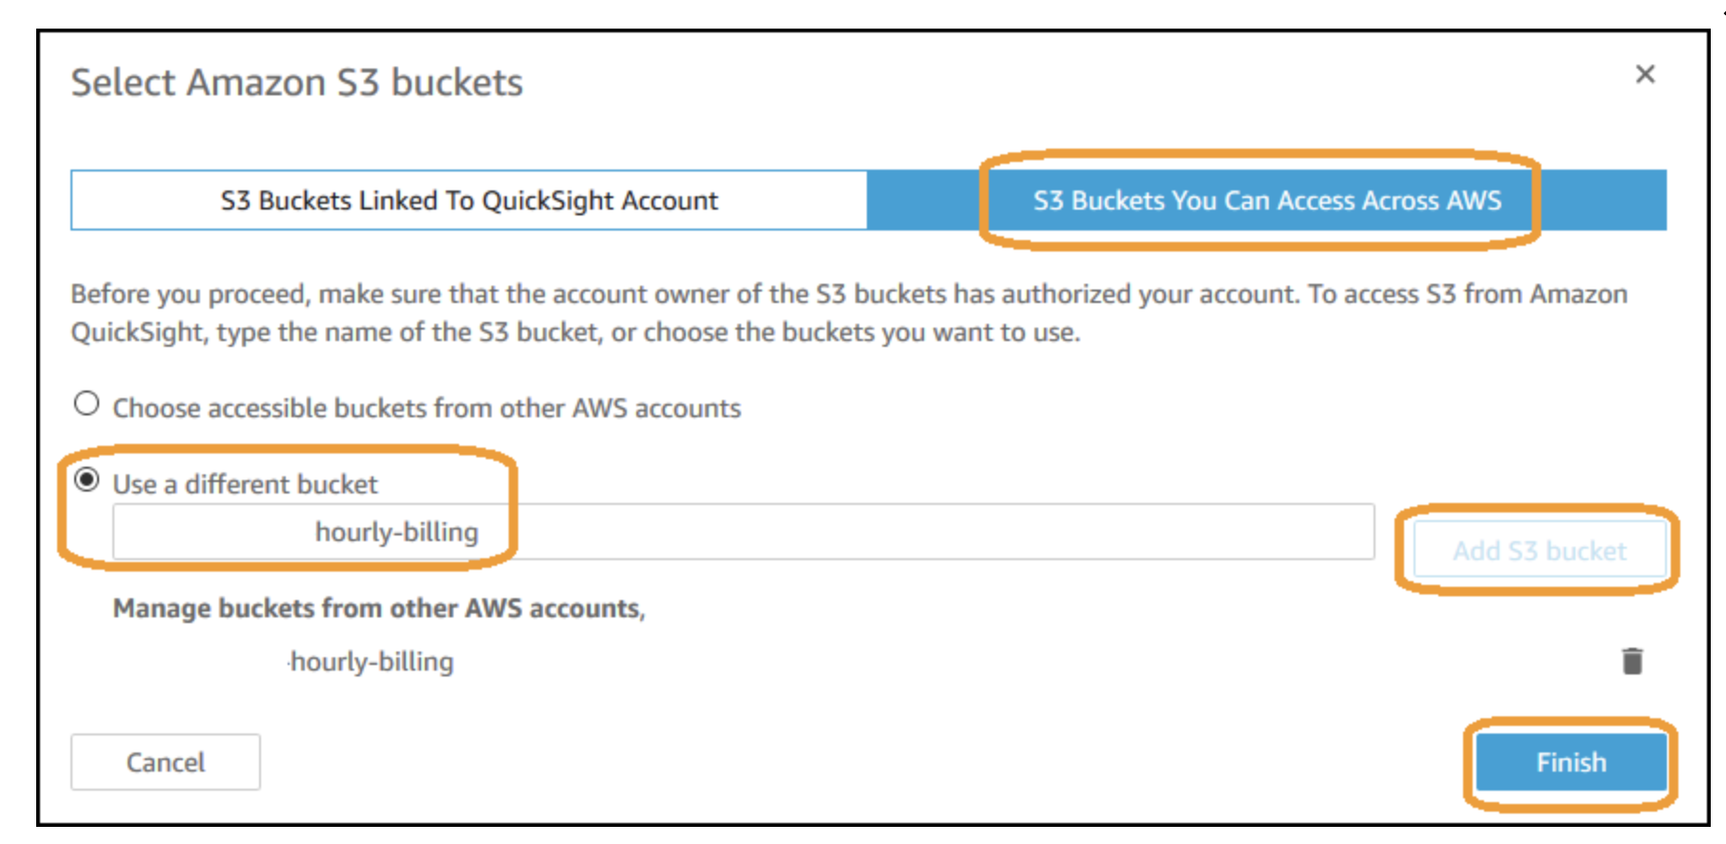

Click **Finish**:

